Fife Whole Family Wellbeing (WFW) Sleep Project and Sleep Network Event - June 2026
On 2 June 2026, the Fife Sleep Network Event brought together 136 practitioners at the Bay Hotel, Kinghorn, for a dynamic multi-agency learning and networking opportunity. Supported by Fife Health Charity, it reflected strong collaboration across NHS, Social Work, Education and Third Sector partners to improve outcomes for children, young people and families.
The event marked a key milestone within the Fife Whole Family Wellbeing (WFW) Sleep Project, funded through the Whole Family Wellbeing Fund. The project focuses on early intervention and prevention by developing a skilled, confident workforce able to provide evidence-based sleep support before families reach crisis point. In total, 404 people across the multi-agency workforce have completed Sleep Advisor or Sleep Counsellor training.
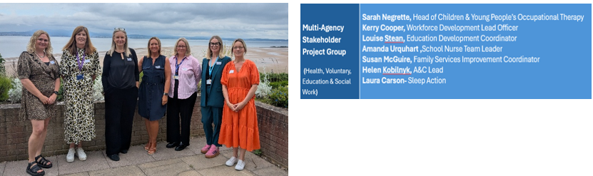
The event brought together practitioners who had completed Sleep Action Sleep Advisor and Sleep Counsellor training. It strengthened understanding of the project’s aims, shared learning and evaluation, and supported confidence in delivering sleep support across services. Outcomes included enhancing workforce capability, enabling peer learning and identifying priorities for sustainability across Fife.
A key theme was the shared recognition that sleep is fundamental to physical and mental health, learning, emotional regulation, relationships and wellbeing. There was strong energy and enthusiasm in the room, alongside a collective commitment to making sleep everyone’s business and ensuring it is routinely considered in support for children, young people and families.
Practitioners highlighted that sleep support can be one of the most effective forms of early intervention, with wider improvements often seen in family resilience, wellbeing and day-to-day performance. This was illustrated through practice insights from Gallatown Nursery, the Muirhead Outreach Project and School Nursing, who described the positive impact of embedding sleep support within their work.
Structured “connect and learn” sessions enabled participants to reflect on implementation and consider what is needed to embed sleep support more consistently and sustainably. Feedback is being collated and themed, with key insights to be shared across partners to inform next steps.
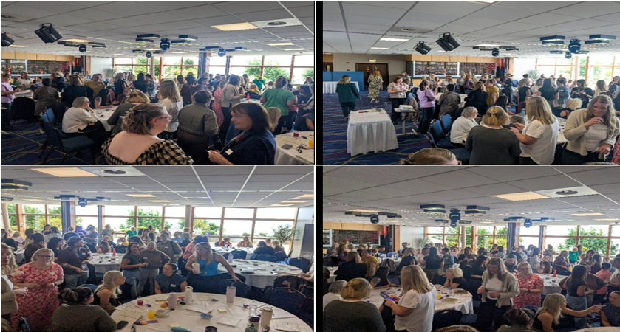
The Fife WFW Sleep Project has demonstrated measurable impact, including significant improvements in workforce confidence, knowledge and skills following training, and growing evidence that sleep is now being routinely considered in practice. This supports the long-term ambition of a whole-system approach where consistent, evidence-based sleep support is embedded across services.
Sincere thanks are extended to all speakers and contributors who shared their learning and experience and brought the impact of this work to life. Particular thanks to Helen Kobilnyk for her invaluable support in organising the event, Sleep Action for their continued partnership, and stakeholders whose commitment since January 2024 has been central to the project’s success.
The energy, collaboration and shared purpose demonstrated at the event highlight the strong foundations in place to build a sustainable, system-wide approach to sleep support in Fife, recognising that improving sleep is both impactful and essential to better outcomes for children, young people and families.
A Call To Action!
1. Read and share the Sleep Action Manifesto Sleep Action Manifesto V1.1 10-25 (web) It outlines the case for change and national vision.
2. Sign and promote the national petition: Petition · Make Sleep a Core Part of Scotland’s Curriculum – bring sleep into the classroom! - United Kingdom · Change.org

