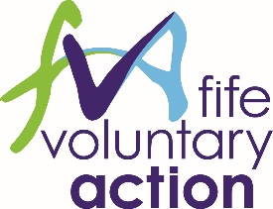

**Voluntary Sector Children’s Services Forum**

**Thursday 23rd May 2024 – 10am – 12pm**

**New Volunteer House, Kirkcaldy**

**Agenda**

1. Welcome and Apologies
2. Minutes of the last meeting held on 29th February
3. Strategic Commissioning Feedback - Mike Bell
4. Scottish Child Law Centre – Law Clinic Survey
5. Co-production update –Mark Hutchison & Susan McGuire
6. Forum Development – New Structure Discussion
7. Voluntary Secor Representation Vacancies

* Chair (VSCSF) – Children in Fife Representative
* Child Protection Committee (CPC)
* CPC Workforce Development Group
* CPC Quality Assurance & Data Group
* Physical Activity & Health Weight Group

1. Voluntary Sector Representation Updates

* Updates from group representatives

1. Sector Updates

* Child Wellbeing Pathway Refresh
* Multi Agency Practice Development Sessions
* Sleep Advisor Training
* UNCRC Incorporation

1. Round Table: Updates, Information, News and/or Issues from members

***Next meeting dates***

* ***Thursday 29 August 2024, 10.00 - 12.00, Caledonia House, Glenrothes***
* ***Thursday 07 November 2024, 10.00 - 12.30, Caledonia House Glenrothes***