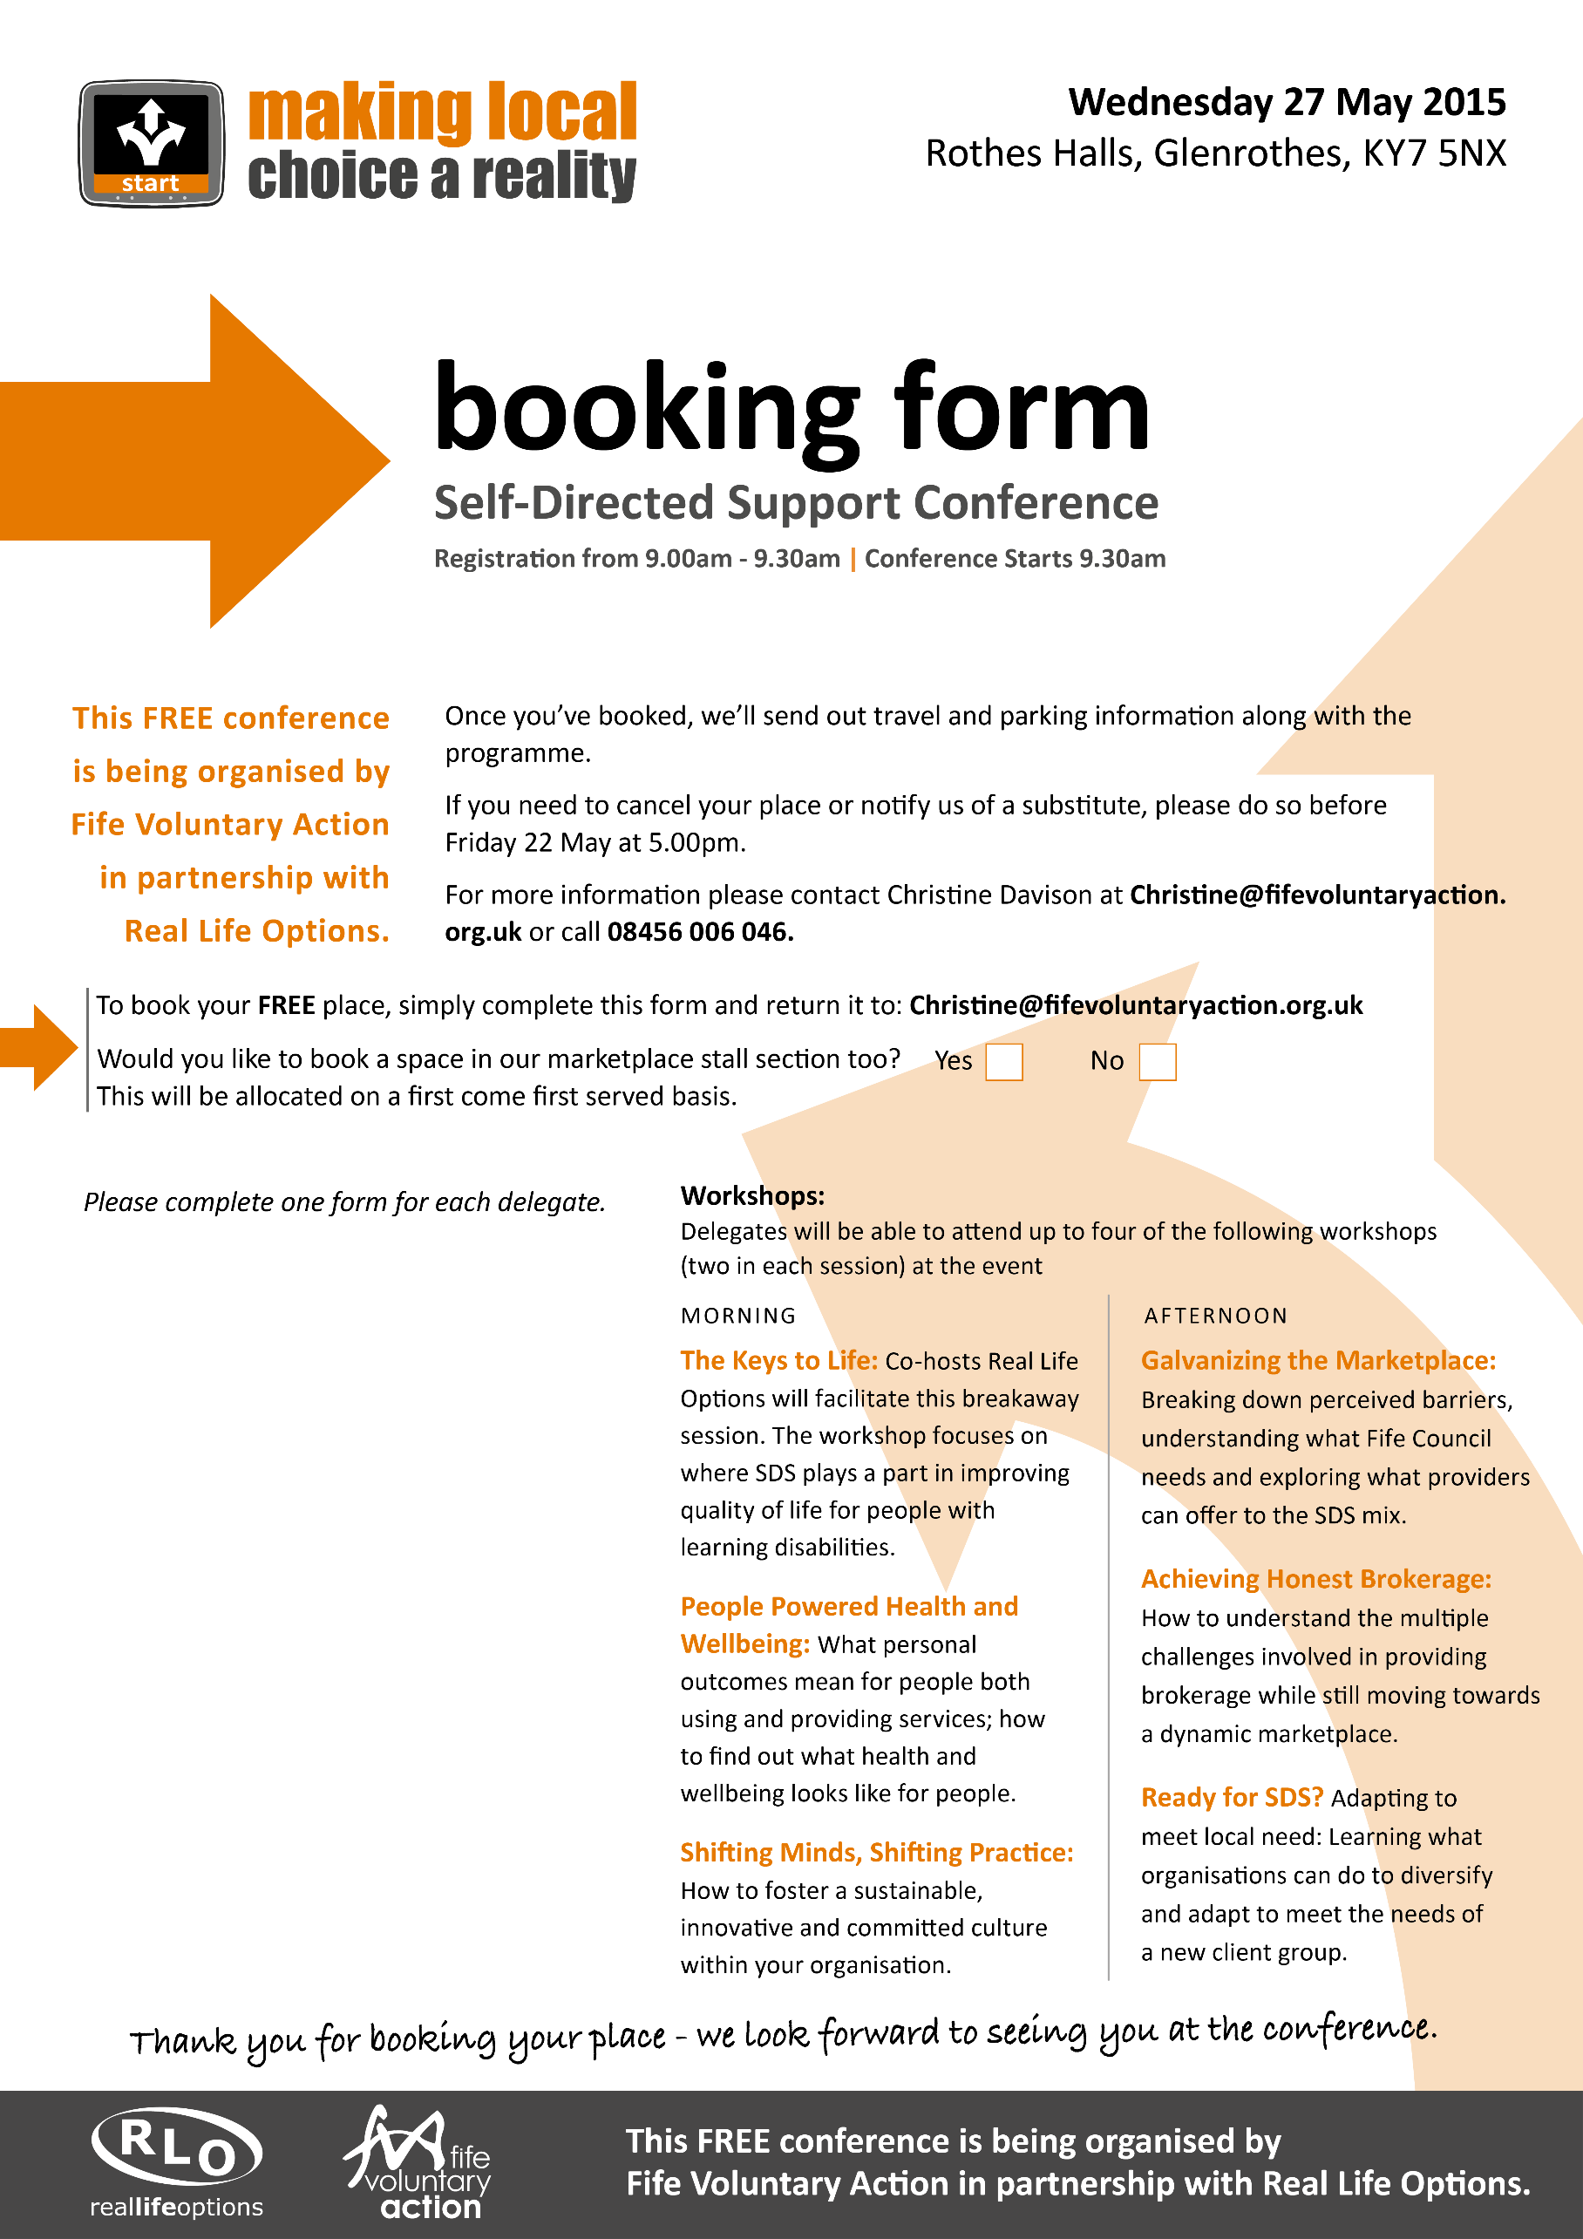

Please state yes or no:

y

Name:
Job Title:
Organisation:
Address including postcode:
Telephone:
E-mail:

