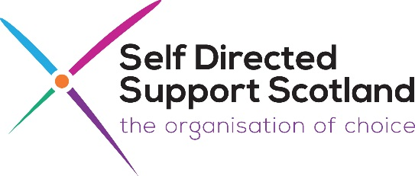
Registration Form:
Please complete 1 form for each person
‘Self Directed Support: The Reality’
‘The experience of SDS Implementation in East Scotland’
Wednesday 2nd November
10.30am – 2.30pm – Rothes Hall, Glenrothes

Your details:
Name:
Address:

Tel:
Email:
Local Authority are you live or work in:

Dietary requirements: | Yes or No
Do you have any dietary requirements?
Vegetarian
Gluten free
Soya free
Dairy free
Any other dietary needs (please state)

Access and support: Do you need any of the following: Yes or No
BSL Interpreter
Induction Loop
Easy Read Information
Support during the event
Any other access or support needs (please state)

Please return the form by Monday 24th October to:
Mark Han-Johnston: Email: mark@sdsscotland.org.uk
If you have any queries, please email or call Mark on: Tel: (0131) 4752623

