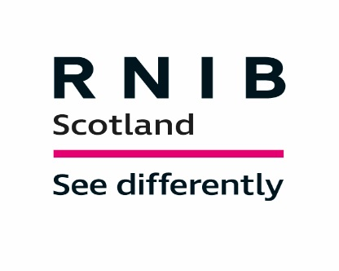
Social Care Practitioner (Crosshill & Kirkcaldy, Fife)
Job reference: REQ0000544
Application closing date: 19/11/2019
Salary: £16,426.00 per annum pro rata (£8.75 per hour)
Hours: Various contracts available, all day time with no evening or overtime hours
Contract type: Permanent (but sessional hours also available)

Job description

Do you have great all round communication skills, enthusiasm and thrive in a busy environment? Do you have a "can do" attitude and want to work with adults who have a learning disability and sight loss? Are you motivated and rewarded by making a positive difference to someone's quality of life?

If so, we have an exciting opportunity for you to be part of the RNIB Scotland Visual Impairment and Learning Disability/Complex Needs Services (VILD). We offer unique, personalised care and support services for people with sight loss and complex needs.

Working with VILD you will learn how to identify hidden sight loss. You will be involved in helping the customer to create their own individual care plan and you will support and encourage development of choice, control and confidence.

This position requires someone with strong values who can provide emotional, social, personal and physical support. You will enable people to develop new skills and participate in activities of their choice including, baking, sensory interaction, walking, music, art, and other various outings.

Applicants must be aged 21 or over and a driver. It is essential that you are able to travel throughout the area/region in a timely fashion to fulfill customer and service requirements. If using your own car, a full clean driving licence with business Insurance will be required. This is to comply with RNIB insurers requirements.

We will try to offer a contract with the number of hours that you need, so at your interview feel free to talk about what would work for you. There are no guarantees; however, it may open the door to a new role.

In return, we can offer an attractive benefits package including a contributory pension scheme, paid annual leave (pro rata) plus public holidays. You will also benefit from a wide range of specialist induction training and have the possibility of commencing SVQ 3 following initial year contract.

If you would like to apply for this great job opportunity please review the documents on www.rnib.org.uk search using the reference for the job,then select "Apply Online" and complete our application form. Remember to tell us how you meet the Specialist Skills, Knowledge and Experience criteria (Section 1 of the person specification). Guidance for completion can be found on each page of the application form.

Appointment is subject to membership of the Protecting Vulnerable Groups Scheme (PVG Scheme) and appropriate references.

We're the Royal National Institute of Blind People (RNIB) and we're here for everyone affected by sight loss. Working for us means working for one of the UK's biggest charities, supporting almost two million people living with sight loss in the UK.

RNIB is committed to being led by our customers (blind and partially sighted people), and one of the ways we do this is through active involvement and engagement in many of our work activities, including the recruitment of new members of staff.

Please be aware that blind and partially sighted customers or volunteers may be involved in the recruitment and selection process for this vacancy; including reviewing job applications and CV's, shortlisting and interviews and selection tests.

RNIB is committed to being an Equal Opportunities organisation and we welcome applications from people with sight loss.

