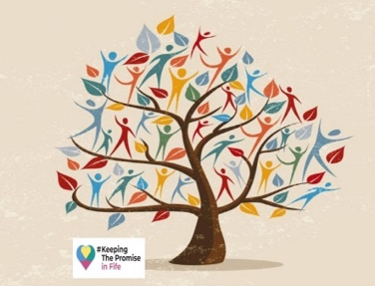
Whole Family Wellbeing
Over the past two years we have delivered Practice Development Sessions that allow multi-agency practitioners to reflect and learn together to ensure collaborative practice in alignment with the Whole Family Wellbeing practice principles and in keeping with the principles of The Promise.
We are offering condensed versions of the PDS that have taken place across all 7 Fife localities between April 2023 and March 2024 and between August 2024 and March 2025 to anyone who may have recently taken up a new role or missed the sessions first time round.
Very insightful, particularly useful to have the opportunity to discuss the scenarios with people from other services and hear how their service would respond
"
"
Offering 1- delivered 2023/2024:
An Introduction to Whole Family Wellbeing
Relationship based practice
GIRFEC Refresh
Trauma Informed practice
BOOKING LINK: https://forms.office.com/e/HU10dLuMJn

Offering 2 Child Wellbeing Pathway- delivered between August 2024 and March 2025
Assessment & tools
Information sharing
Team Around the Child Approach
BOOKING LINK: https://forms.office.com/e/uqnyGnbeY8
Contact – Kerry.cooper@fife.gov.uk

