Role Profile – Outreach Worker

Reports To:
Outreach Team Practice Lead

Role Purpose:
The outreach team delivers a local information, advice and support service for vision impaired veterans living in Scotland. As Outreach Worker you will be expected to work with members to identify and meet their individual needs in order to increase and maintain their independence and enhance their quality of life.
By working as part of the outreach team you will assist in developing excellent working practices and innovative responses to meet our member’s needs.

All roles within Sight Scotland and Sight Scotland Veterans are expected to work to our values and Our Ways of Working framework:

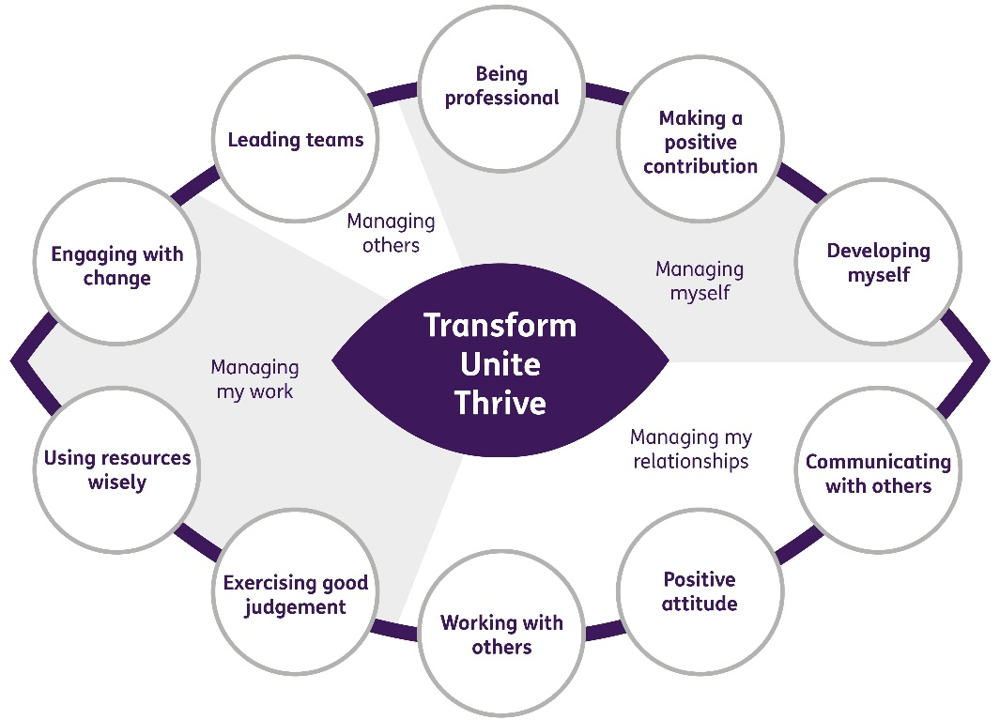

Our Ways of Working - Managing my Work

The main responsibilities and accountabilities of this role are that you will:

- Undertake home visits to members within a wide geographical area
- Meet with and assess individual members to develop an agreed, person-centred action plan
- Work with members to achieve their plan
- Provide information and advice to members
- Work with service users to help them regain the skills and confidence they need to live as safely and independently as they wish
- Refer members to other Sight Scotland Veterans services and other organisations where necessary
- Negotiate and advocate on behalf of members where necessary
- Liaise with other organisations and agencies
- Develop creative and innovative responses to member need
- Maintain all necessary records/databases
- Develop and keep updated a high level of awareness of other relevant services for VI veterans in the local community
- Work as a team with the Practice Leads and colleagues to develop excellent working practices in relation to all aspects of the service
- Contribute to staff meetings and participate in supervision with the Practice Leads and senior managers

Our Ways of Working – Managing Myself and Managing my Relationships

To do this role, you will:

- Have an SVQ level 3 Health and Social Care (or willingness to work toward) or another professional health or social care qualification.
- Have demonstrable experience of working with older people or adults with a vision impairment, those with other disabilities, mental health or service veterans in the community
- Have demonstrable experience of outcome focussed assessment and the principles of person-centred support and co-production
- Have up to date knowledge of the context in which care, support, rehabilitation and enablement are provided in the community for older people or people with disabilities
- Have an understanding of the support needs of people with a vision impairment
- Be able to demonstrate excellent communication skills
- Have the ability to build positive relationships with service users and colleagues
- Be committed to empowering visually impaired people to have choice and control over their lives
- Be responsive to others in order to identify the needs of those who use the service and creative and innovative in finding ways to meet those needs
- Have excellent time management skills to plan, prioritise and manage your workload
- Have the ability to work calmly under pressure
- Have the ability to adapt to change and respond positively to non-routine situations

To do this role it is desirable if you:

- Have additional relevant qualifications
- Have experience of working with service veterans
- Have experience of working with people with vision impairments
- Have experience in a rehabilitation setting
- Have evidence of continuous development and a willingness to undertake further training & development
- Have knowledge of statutory and 3rd sector provision in respect of people with a vision impairment
- Have knowledge of statutory and 3rd sector provision in respect of service veterans

On a day to day basis you will work with different people and teams, these could be:
- Colleagues
- Other Sight Scotland services
- Senior Colleagues
- Volunteers
- Members
- Members families/carers
- External Agencies and relevant partners

Requirements of this role are:
- You are a member of the PVG scheme (paid for by Sight Scotland Veterans)
- You will have a 6 month probation period
- That you participate in all staff training and development and maintain your own professional development
- You understand, and be committed to Sight Scotland Veterans aims, principles and equal opportunities policies
- You will wear the appropriate PPE in accordance with current guidance for the role.
- Good IT skills with a good knowledge of Microsoft office packages
- Understanding of and ability to maintain confidentiality
- That you will have a flexible approach to working hours is expected to reflect business needs
- Have the willingness to undertake considerable travel in a wide area in order to visit members in their own homes (in some cases this may necessitate overnight stays away from home)
- That you will have access to a vehicle for use on the job and a valid driving licence.
- You have a suitable home working environment

What we can offer you:
- Generous annual leave entitlement which increases after 4 years’ service
- Generous pension scheme
- Discounts for Carers
- Access to learning and development opportunities
- Employee Perks through the Employee Assistance Programme
- Cycle to Work scheme
- And many more, please visit our website for more information

This job profile is not exhaustive. The duties of the post holder may be reviewed from time to time and the employee may be called upon to work in other locations within Sight Scotland Veterans.

