**LinkLiving Moving On Up – Referral Form**

|  |  |
| --- | --- |
| Client Name: |  |
|  |  |
| Address: |  |
|  |  |
| Phone: |  |
|  |  |
| Email: |  |
|  |  |
| Date of Birth: |  |

|  |  |
| --- | --- |
| Preferred Contact method: |  |

**Referral Agency**

|  |  |
| --- | --- |
| Name: |  |
|  |  |
| Agency: |  |
|  |  |
| Phone: |  |
|  |  |
| Email: |  |

**Please tick which area applies to you?**

|  |  |  |  |
| --- | --- | --- | --- |
| Falkirk |  | Fife |  |

Z:\Communications Team\Brand Templates August 2014\Logos\Other logos (not Link)\accreditations\Investors in Young People\IIYP.jpgPositive about disabled peopleHealthy working lives_Logo_Gold_RGB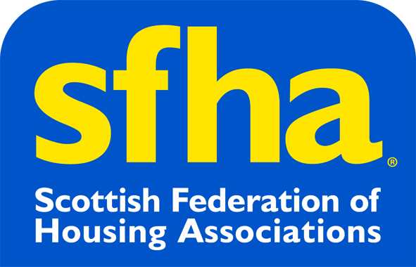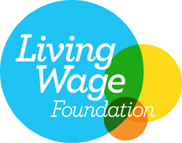**Additional information about the client**

|  |
| --- |
|  |

LinkLiving Limited is a company limited by guarantee registered in Scotland under the Companies Acts, Company Number: SC220855, Registered Office: Link House, 2c New Mart Road, Edinburgh, EH14 1RL. It is a Charity registered in Scotland, Charity Number: SC032418. Part of © the Link Group 2019.