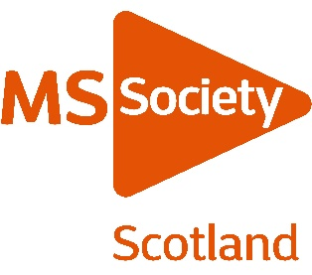
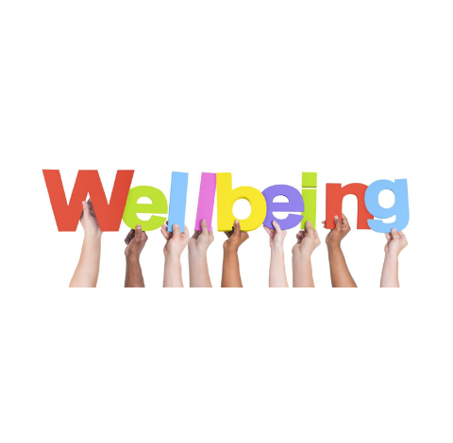
Our MS Wellbeing Hub is a one-stop shop of virtual support and information. These free services are available to anyone with MS and their families in Scotland.
In excess of 350 people have already benefited from the Hub including Carla, 35 from Lanarkshire who was diagnosed with relapsing MS in 2013. She accessed the MS Wellbeing Hub to receive a course of online physio, having fallen a number of times just before lockdown. She told us ““It was really worthwhile and I feel confident enough that I’m going out walking a few miles a week. I’m comfortable to go out on my own without that fear of talking a tumble in the street anymore which, from just four weeks of online physio sessions, is absolutely incredible.”

The service on offer are Scotland wide and include:

- Counselling

- Physiotherapy Support

- One to One Information Support

- Wellbeing Group Sessions – a programme of sessions offering information, learning and most importantly-some fun. These include tai chi, Pilates, meditation and much more.

For more information, https://www.mssociety.org.uk/care-and-support/local-support/wellbeing-hub to access any of these services or make a referral please contact wellbeingscotland@mssociety.org.uk or call 0131 335 4050.

You may also be interested in activities which our living well teams are providing and full details of these are on our website follow this link for information https://www.mssociety.org.uk/care-and-support/everyday-living/living-well-with-ms-sessions

Finally our Helpline is there for any additional queries / support by calling 0808 800 8000 or email helpline@mssociety.org.uk

