LinkLiving: Sporting Chance (16-24) - Referral Form

Name
Date of birth:
Address:
Preferred contact number:
Email address

Referral Agency Details

Organisation Name:

Contact Name:
Contact details:

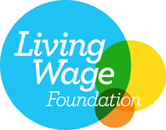
Additional information about the young person that would be useful for us to be aware of

Please return completed form to catherine.sim@linkliving org.uk who will be in touch to arrange an initial appointment with the young person.

LinkLiving Limited is a company limited by guarantee registered in Scotland under the Companies Acts, Company Number: SC220855, Registered Office: Link House, 2c New Mart Road, Edinburgh, EH14 1RL. It is a Charity registered in Scotland, Charity Number: SC032418. Part of © the Link Group 2019.

