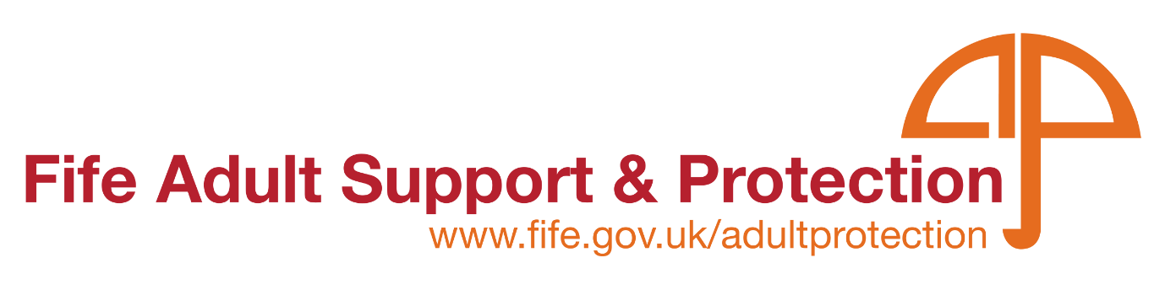

Hoarding Intervention Training 2023

The Adult Support and Protection Committee are pleased to offer Hoarding Intervention Training throughout 2023.

The training will be delivered in person by Linda Fay, Director of Life Pod for;

Frontline Practitioners within all Partner Agencies, Managers, Supervisors, Support Workers, and the voluntary and third sector who are involved with providing support to people within the community.

Venue: The training will be held in person at Fife Volunatry Action, Caledonia House, Pentland Park, Glenrothes, KY6 2AL

From 09:30 – 16:30

Dates:

16th January, 27th April, 26th May, 19th June, 25th July, 23rd August, 28th September, 27th October, 22nd November, 12th December

At the end of this course participants will be expected to;

Be able to recognise hoarding behaviour,

Understand the cognitive-behavioural model of hoarding, and

Identify effective interventions

Spaces are limited so please be sure to book as soon as possible.

All Fife Council Employees must book through Oracle. Click on the learning tab and search for: ASP Hoarding Interventions. For non Fife Council Employees please book using the form below.

Application Form

If you would like to book a place on the webinar and are not a Fife Council Employee, please fill in the application below and return it to – LearningAdminBusinessSupport@fife.gov.uk

Please be advised that non-attendance without notice is likely to result in a fee being incurred. Our courses are offered free of charge, however, it is vital that notice is given when people are unable to attend to ensure maximum places are offered to colleagues across all services. There will of course be occasions where it is not possible to make contact prior to the start of the course. Please ensure contact is made as soon as possible following to advise of reason for non-attendance.

Date of the session you wish to attend
Name:
Job title:
Organisation / Service:
Address:
Telephone No:
Email Address –
Essential for MS Teams link
Line Manager email

We are currently able to offer this course free of charge.

E-Learning

E-Learning course: Hoarding Essesntials available to access via oracle. This course will be available soon via https://fifecouncil.learningnexus.co.uk/ for partner agencies to access.

