How to Make a Referral
for a
Home Fire Safety Visit (HFSV)

Guidance for
Partner Organisations

Version No 1.0 May 2018
Contents

Background Page 3

What is a Home Fire Safety Visit? Page 3

Who will benefit from a Home Fire Safety Visit? Page 4

Premises not suitable for a Home Fire Safety Visit Page 5

How do partner organisations make a referral for a Page 5
Home Fire Safety Visit?

Problems referring ? Page 8

Assistance from SFRS Page 9

Background

Over the last few decades, the Scottish Fire & Rescue Service (SFRS) has changed.

Back in the 1980’s firefighters attended a lot of fires and other incidents. We did an excellent job of dealing with those fires and rescuing people.

As we worked through the 90’s we were very successful at getting people to fit smoke alarms in their homes. As a result of this, many fires were detected faster meaning property damage and loss of life were reduced.

We didn’t stop there.

In the New Millennium we started visiting peoples’ houses, not to just promote smoke alarm ownership but to educate people on how they could prevent fires occurring.

By 2010 we came to understand that older people were more vulnerable than others so we focussed our attention on these people. As we approached 2015 we identified a clear relationship between our risk groups and those prone to slips, trips, falls and ill health.

Throughout 2018 and beyond our aim is to continue working with partner organisations to keep residents within our communities safe from fire and, where applicable, improve their health and wellbeing.

What is a Home Fire Safety Visit (HFSV)?

A HFSV is a comprehensive assessment that examines the levels of fire risk within the home. It usually takes around 30 minutes and is conducted by trained firefighters or Community Action Team members. They are free of charge and include fitting long life smoke detection, where applicable.

Upon request and resources permitting, it is possible to arrange a joint HFSV where a partner agency is also in attendance with SFRS personnel.

It should be borne in mind that where an operational fire crew from a local community fire station conduct the visit it is possible that they may be called away to an emergency incident whilst in someone’s property. This is due to fire crews being available to attend emergency incidents 24 hours a day, 7 days a week.

Where applicable, positive intervention, onward referral and/or signposting to partner organisations will be made in an attempt to improve the fire safety, health and well-being of residents throughout Scotland.

Who will benefit from a Home Fire Safety Visit?

Although HFSVs are available to everyone, we are asking our partner agencies to refer those individuals who identify with a number of risk factors. These can include age, living alone, limited mobility, dependency on substances and lifestyle choices. In addition, we will use the data we collect to better target “at risk” people.

If you have safety, health or wellbeing concerns about anyone you support in a working capacity who meets one or more of the criteria listed below, submit a referral for a HFSV. Please note that permission must be gained from the service user before you pass their details to SFRS.

- Over 65 years of age
- Lives alone
- Has a physical and/or learning disability
- Has any sensory impairment
- Is known to be substance or alcohol dependent
- Unable to protect themselves from harm
- Experiencing mental health problems
- Fire risk concerns identified, for example burn marks on bedding, furniture or carpets; electrical faults in the home; unsafe practices with fire, cooking or heating; hoarding; the occupier smokes.
This graph shows a basic profile of people who die in fires.

Source: SFRS Fire Fatalities and Casualties
Analysis Report 2013-2016

Premises not suitable for a Home Fire Safety Visit

SFRS will not conduct a HFSV in any relevant premises as defined in the Fire Scotland Act 2005, together with any premises which come under the scope of the Care Commission.

Some examples are shown below, however, there may be others in addition to these:-

- Men’s/Women’s Hostels
- Student Accommodation
- Staff Accommodation
- Nurses Quarters
- Care Homes
- Children’s Homes
- Holiday Accommodation
- Caravans
- Properties being used for child minding services if the request is in connection with that service
- Houses in Multiple Occupation. NOTE: An HMO is a property rented out to at least 3 (unrelated) people who share the bathroom or toilet and kitchen

How do partner organisations make a referral for a Home Fire Safety Visit?

A specific URL to SFRS interactive Community Safety Engagement Toolkit (CSET) pre risk rating form has been set up for partner organisations to make a referral for a HFSV on behalf of a client/service user.

Please ensure you have the persons’ permission before making the referral.

The link can be accessed through the Scottish Fire and Rescue Service website and the referral made by following the undernoted steps.

1 Go to www.firescotland.gov.uk
On the front page of the Scottish Fire and Rescue website, scroll to the bottom where you will see an advert to request a HFSV.

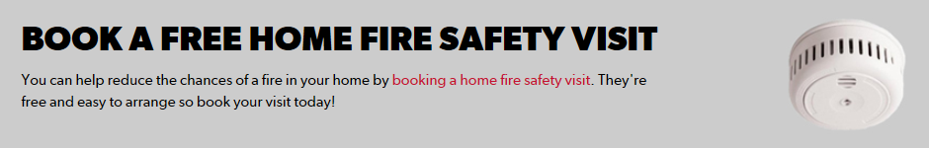

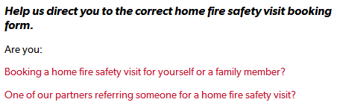

Choose the “partner agency” link

2 Register for an account if you have not already done so.

The partner agency link requires the user to register with a user name (their work email address) and a password of their choice. This ensures a secure connection between the user and SFRS. If the same computer is used partners shouldn’t have to log on every time a referral is made. However, if they use a different computer the system will require them to log on to confirm identity.

Partner organisations do not get full access to the SFRS CSET application. The link opens up a risk rated referral form which, depending on the answers given, lists each request in order of who is deemed most at risk.

3 Choose the address of the person you want to refer and complete the risk rating questions. Most addresses should be listed as the address gazetteer is updated periodically.

Make every attempt to ensure accuracy when choosing the address, especially in relation to flat numbers and the spelling of street names.

4 Complete the form. Each question asked has a score attached to the answer given. This allows us to list each request, with those deemed most at risk given priority. At the conclusion of the visit, if the post risk rating outcome is “high” risk a re-visit will be offered to the occupier one year after the date of the visit.

Assistance on how to answer some of the questions can be found undernoted.

How Did You Hear About Us?

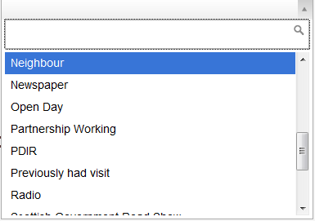

Choose “partnership working”

Referrer Details
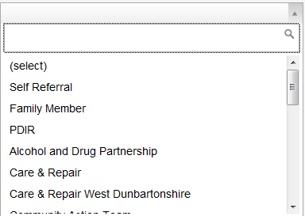

Choose your partner organisation name from the drop down list.

Question 18

As you are a partner organisation referring a service user and the visit has yet to take place please answer “YES (PREVISIT)”.

Referrers Details

Please ensure you choose your organisation name from the drop down and state your own name and contact telephone number in case we need to update you after the HFSV has been conducted.

Your email address can be typed within the “comments” freetext box. This is an efficient way of communicating with you outwith office hours.

Any Other Relevant Risk Information

If you wish to state any further information please use the freetext box at the bottom “any other relevant risk information”. This box can be used to highlight information, examples of which are undernoted. In relation to personal or confidential information, please take data protection into consideration when adding freetext comments.

For example, we do not need to know the exact ailment or medication taken by an occupier. Instead it more useful to know the effects of any medical issues such if it is known that they would be unable to evacuate in an emergency situation.
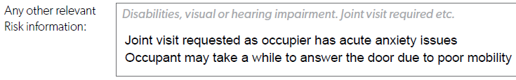

5 Submit the information. When the user completes the referral and hits the “submit” button, within 3 to 10 seconds the HFSV request will be added to the appropriate station list of outstanding visits in accordance with the address of the property.

The above displays how partner organisations can securely share personal data and supporting information in relation to a service user with SFRS. Partners are requested to use the above detailed method of referral rather than emailing or posting correspondence directly to SFRS employees.

Problems referring?

An error message such as “you do not have permission to perform this action” will be displayed when there is a problem referring. Possible solutions include –

1 Ensure you are using this address/link to access the pre risk rating form: https://cset.firescotland.gov.uk/thirdparty/hfsv/requestvisit

2 Have you supplied your local SFRS contact with your domain name? (For example SFRS domain name is firescotland.gov.uk)

3 Could there be expired security information in your web browser? To diagnose and correct this issue follow the steps below:

3.1 Log out of the hyperlink by clicking the dropdown menu arrow next to your name in the top right of the application inside the blue button, then click the “Log Out” button which appears.

3.2 Close and reopen your browser then reopen by using this link: https://cset.firescotland.gov.uk/thirdparty/hfsv/requestvisit and attempt to login again.
3.3 If this does not resolve the issue then please use the link below to find the instructions to reset your browser cache and follow them before logging in again.
(This may cause you to lose data such as browsing history and saved logins and passwords from your web browser depending on which options are selected.)

Instructions to reset your browser cache:
http://www.wikihow.com/Clear-Your-Browser%27s-Cache

4 If you do not receive your confirmation in your work email inbox, check the spam/junk folder.

Assistance from SFRS

If, after trying the above solutions you are still having trouble referring, please get in touch with your local SFRS contact. He or she can then take steps to request additional assistance from SFRS ICT Service Desk, where required.

Thank you for working in partnership with the Scottish Fire & Rescue Service.

How to Make a Referral For a HFSV Version Number 1.0 May 2018

