2022

Partner Organisations Catalogue
Fife Council eLearning

Introduction

As part of Fife Health and Social Care Partnership, Fife Council want to support learning and development as widely as possible.
Up until November 2020, all Fife Council eLearning was hosted on an internet website with some of this being available without needing to login. We then moved onto a new Learning Management System which, for Fife Council staff hosts all training opportunities.
To ensure that we still support the learning of Partner Organisations, as much of the relevant eLearning that we can has been kept on our internet website and we would like to make this easier for you to know what is available and how to find this.
To support this, this document provides a list of available courses, with a short description and a link to the course on the website.
To view all course available, use the link below and then click on the Partner Organisation banner on the website.

Fife Council Partner Organisations VLE (learningnexus.co.uk)

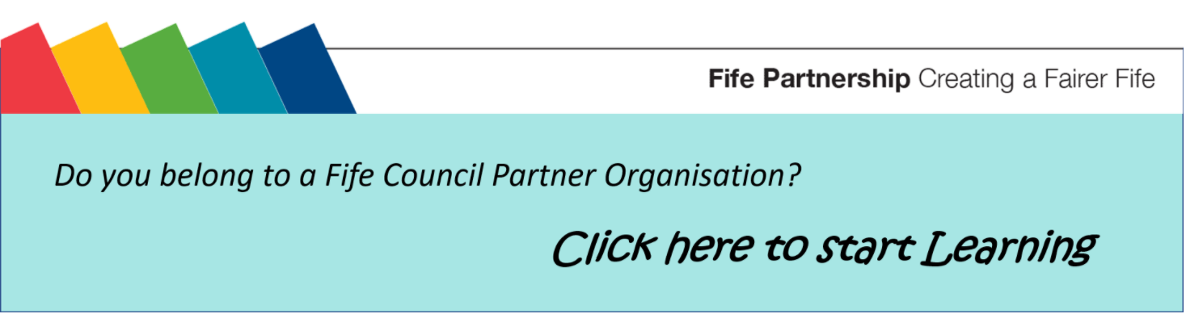

You may also find it useful to look at some of the external resources we make use of and these are detailed in Appendix 1
Appendix 2 provides some guidance on taking a screenshot if you need to keep evidence of completion.

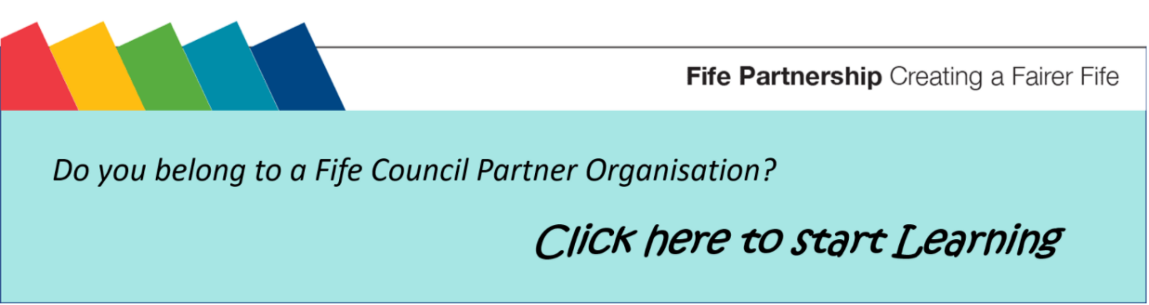

List of courses and their links (Ctrl + Click on course title to open the link):

Adult Support and Protection Awareness

Everyone who works in social work or social care MUST have knowledge and understanding of adult support and protection - what it is, who it is aimed at, what to do if you are concerned. This course will give you the awareness needed for your role.

These additional eLearning will enhance your understanding of adult protection:

- Problematic Alcohol and Drug Use

This course is for anyone who works with adults and older people and will help you:
- Understand that self harm is included as part of the criteria defining an adult at risk of harm
- See beyond problematic alcohol & drugs use, (that may be part of a presenting problem), to ask if the adult may be at risk of harm
- Appreciate the impacts and risks of problematic alcohol and / or drugs use when an adult may have been harmed
- Consider how to respond in a way that is most likely to provide most benefit for the adult.
- Understand the complexity of issues that may arise

- Professional Curiosity

This eLearning will support you to understand:
- what Professional Curiosity is
- why it is important
- how to use the techniques

- Undue Pressure

This will help you to understand
- What undue pressure is for an adult at risk of harm
- Appreciate the signs that suggest undue pressure
- Comprehend the impact of undue pressure
- Understand the barriers to reporting or receiving help where there is undue pressure
- Know what to do if you encounter an adult who may be subject to undue pressure

Advocacy in Fife

Using this resource, you will learn:

- what advocacy is and what it is not;
- the importance of advocacy;
- the principles and standards
- the types of advocacy; and
- services available within Fife.
Autism Informed Practice

The NHS Education for Scotland Autism Training Framework, Optimising Outcomes, is a framework for all staff working with people with Autism Spectrum Disorders (ASD), their families and carers.

The Framework identifies 4 levels:
1. Informed Practice Level
2. Skilled Practice Level
3. Enhanced Practice Level
4. Expertise in Autism Practice Level

This e-learning course, created in collaboration with NHS Fife Psychological Services, covers the Informed Practice Level. This describes the essential knowledge and skills required by all staff working in health and social care settings including the individual’s home as well as anyone who may come into contact with someone with ASD as part of their work eg health receptionist.

Care at Home Suite

This course has been developed by Fife Council’s Home Care Training Team to provide the key components of what was normally delivered as part of Core Training - their induction for new staff. It covers areas such as Fife Council Support Plan familiarisation, Personal Care, Continence and Catheter Care and PPE.

Child Protection Awareness

Similar to Adult Support and Protection training, all registered staff, regardless of whether working with adults or children, need to have a knowledge of child protection.

Additional Child Protection eLearning:

- Protecting Children in Scotland
This course is aimed at staff who work with Adults and Older People. If you work directly with children and/or families, please complete the CPC GIRFEC and Child Protection training or Child Protection Awareness

- CPC GIRFEC and Child Protection
This course is provided by Fife Child Protection Committee. It is aimed to provide an understanding of child wellbeing and child protection for those who work directly with children and families.

- CPC Preparation for Court
This course is provided by Fife Child Protection Committee. It aims to provide information and support to anyone who may be asked to attend court or a Children's Hearing. It is aimed to support anyone regarding of the service or agency you are representing.

- Child Sexual Exploitation

This is a short Child Sexual Exploitation (CSE) online course designed to provide an awareness or refresher for:

  - all staff who work with children and young people,
  - those who may have contact with children and young people whilst carrying out the roles and responsibilities of their post.

Coach Approach

This course is for all staff who have conversations! It may be of particular benefit to those with line management responsibility or who work directly with clients, customers and the community. The aim of this course is to introduce you to the coach approach used in Fife Council - to give you the tools and understanding to give it a try.

Community Empowerment

This introductory course is designed for staff working in local communities. After completion of this course learners will have knowledge and understanding of:

· The Community Empowerment (Scotland) Act 2015
· What Community Planning is?
· What asset transfer is and how to apply
· What a participatory request is and what it can be used for
· How participatory budgeting works and;
· What support is available to community groups in Fife and Tayside

Diversity and Equality

Equality and diversity are essential components of health and social care. Good equality and diversity practices make sure that the services provided to people are fair and accessible to everyone. This course makes use of a short video and fact sheet.

Domestic Abuse Awareness Raising Tool (DAART)

This will provide you with the link to an external resource: This online tool is a learning resource for professionals. It's an awareness-raising resource and serves as an introduction to domestic abuse and coercive control. The tool provides an overview of the main considerations when responding to domestic abuse, however it does not replace specialist domestic abuse training.

Duty of Candour

This course should only be completed by Fife Council Partner Organisations who work in a Social Care setting. This e-learning course will inform you of the Duty of Candour legislation and outlines the steps you need to take to comply with the Duty of Candour.

Dysphagia (Level 1)

Dysphagia is a condition that affects people's ability to eat, drink and swallow. In May 2020, a Competency Framework outlining the skills and knowledge required for Health and Social Care staff was published. Everyone working in Health and Social Care need to understand what dysphagia is and the signs and symptoms of this.

This course makes use of existing external resources. There is also different guidance, depending on whether you support someone who is elderly or who has a learning disability, which you should read.

Dysphagia (Level 2)

In line with the Eating, Drinking and Swallowing Competency Framework, Dysphagia Level 2 training is for all staff who prepare food for, or support people with their eating and drinking, who have an eating and swallowing plan or diagnosis of dysphagia. As with Level 1, a range of resources have been used to support learning.

Dysphagia Level 1 training must have been completed first.

Emergency First Aid

Emergency First Aid training is a requirement for many roles in Health & Social Care. Certified training is required for some staff.

During the COVID-19 pandemic, this e-learning course was developed to act as an interim measure for those who were waiting to attend certified training, or who wanted a refresher prior to their certification renewal. It can also be used by those who do not require certified training, but would like to know more about delivering first aid.

PLEASE NOTE: if you require certified training this is NOT a replacement.

Fife Council: Data Protection

Although titled Fife Council, this course provides guidelines relating to the General Data Protection Regulation (GDPR) and the Data Protection Act 2018. This module should be completed by those who deal with personal and special category data as part of their daily job. It is not just relevant to those working in the Council.

Food Hygiene Awareness for Adult Services

If you are involved in the storage and/or preparation of food for other people, it is important that you are able to carry out these tasks in a way that ensures their health and safety is not put at risk. This course covers the following areas:
- Your legal responsibilities
- Food safety
- Personal hygiene and your responsibilities
- Hazard Analysis and Critical Control Points (HACCP)
- Maintaining high standards of cleanliness
- Temperature control
- Safe food practices (including cross contamination)
- High risk foods

Food Hygiene Awareness for Care at Home

This course is intended for staff within Care at Home Services who are directly involved in food preparation and/or food handling. The course is designed to give participants a basic knowledge of food safety, causes of food poisoning, measures for prevention and how these apply in their work environment.

Fuel Poverty
This short eLearning will help you understand what Fuel Poverty and Extreme Fuel Poverty is, the signs someone may be experiencing Fuel Poverty and where you can direct them to for help.

Human Trafficking
Human Trafficking has become a key focus for the Scottish Government in recent years who have published the 'Trafficking & Exploitation Strategy 2017'. This is an awareness programme designed to provide staff from all agencies with a basic understanding of the issues relating to the human trafficking of children and adults.

Infection Control for Home Carers

Infection Control has never been more important. This course is designed to give participants a basic knowledge of the hazards posed by infections, the ways in which infections are spread and the precautions you can take to break the chain of infection.

Infection Control

There is a very good free eLearning available on the SCIE website. The link will take you straight to their website rather than our Learning site. This course is used for staff in adult and older people services.

Medication – Safe Administration

This learning resource will explain the principles and good practice that you need to follow when supporting people to take medication, from simply prompting to providing physical help to ensure that a person can take the medicines that they need. The course includes a link to the SSSC Safe Administration of Medication. This should be completed prior to doing the assessment included in the e-learning.

There are 3 modules:

- Principles and good practice
- Understanding medication
- Practical considerations

Seated Exercises

This course will support you if you work with anyone who is elderly or frail and who would benefit from some seated exercises.

Self-Directed Support

Self-Directed Support (SDS) is an approach to providing support services. Every stage of the SDS journey from assessment and support planning to the review of the outcomes is carried out with the supported person at the centre of the process. Starting by considering the individual's strengths, needs and goals SDS enables people to choose and direct their care and support to meet their agreed outcomes. With the right support, advice and information, the supported person knows best what they need.

Rather than being a specific course (which is under development), there are a range of resources to help you understand what SDS is and who may benefit from this.

Self-harm and Suicide – Supporting Young People

This course is designed to complement the existing guidance for all adults who work with young people in Fife and provide all professionals with a shared framework for understanding, identifying, assessing and helping young people at risk of self-harm or suicide.

Trauma Informed

The Scottish Transforming Psychological Trauma Framework outlines four practice levels.

  - Trauma Informed
  - Trauma Skilled
  - Trauma Enhanced
  - Trauma Specialist

E-Learning is available at Tier 1 (Trauma Informed) and Tier 2 (Trauma Skilled). Tier 1 training is suitable for all employees in the workforce, irrespective of role. Whilst Tier 2 is for anyone who is working directly with someone who are likely to have experienced trauma.
- Becoming Trauma Informed
- Developing Your Trauma Skilled Practice

Understanding Huntington’s Disease

This is an awareness raising eLearning for anyone who is supporting someone who has Huntington’s Disease.

APPENDIX 1: External Learning Resources

SSSC:
- Enhanced dementia practice resource for social workers and other professionals (sssc.uk.com)
- Dementia: Personal outcomes for people living with dementia
- Dementia: Understanding dementia
- Dementia: understanding stress and distress
- Supervision (stepintoleadership.info)
- Induction for Social Care
- Preparing for Practice

OTHER SOURCES:
- Skills for Care: End of Life Care this resource summarises key points to note and includes useful links for further information.
- For staff with a lead role in planning for end-of-life care, this online course, End of Life Care: Challenges and Innovation, through the University of Glasgow Future Learn site can be accessed for free (for 3 weeks only) when you register.
- Learning Disability eLearning from MindEd offers a wide range of opportunities to increase knowledge and awareness of learning disability. Available courses include Learning Disability Awareness, Learning Disabilities and Challenging Behaviour, Learning Disability and Mental Health and Learning Disabilities and Autism.

APPENDIX 2: How to take a screenshot for evidence
It is recommended, so you can evidence your learning, that you take a screenshot of the final assessment or final screen of each eLearning with the date you completed.
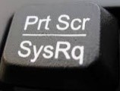
To take a screenshot on a laptop or PC (copy of what is on your screen):
- Press the prt scr button on your keyboard
- Open MS Word, new document
- Click anywhere in the blank document
- Paste the screenshot (Ctrl + V)
- Save the document (Ctrl + S)
PLEASE MAKE SURE YOUR SCREENSHOT INCLUDES THE NAME OF THE COURSE
AND RECORD THE DATE COMPLETED ALONG WITH YOUR SCREENSHOT
If you have completed the course on a tablet or smartphone, then usually, to take a screenshot you press the ‘home’ button and ‘power’ button at the same time, holding for a second before releasing. In some cases it may be ‘volume’ and ‘power’ buttons.
This should add the screenshot to your ‘picture’ folder.
