**Family Support Service Performance Annual Report 2022/23**

**(1st August 2022 – 31st July 2023)**

Executive Summary

This latest annual report for the Family Support Service (FSS) covers the period August 2022 – July 2023. The report focuses on the FSS performance framework which ensures continuous improvement in relation to Processes/ Delivery and Outcomes. The headlines below provide a summary of key learning for each area .

* Referral rates have reduced in comparison to the previous year of reporting , further examination of this indicated that this may be due to an error in counting children rather than referrals per family unit in the previous period .
* Education is the highest referring agency followed by Health and Social Work which is broadly the same as the previous year .
* The service has further embedded the use of Microsoft Forms to obtain feedback from families about the impact of the service . In addition there has been a focus on participation of families in reviewing family support plans – feedback overall is very positive from families .
* Emotional wellbeing and behaviour are the main areas indicating an improvement in outcomes delivered by a whole family strength-based approach .Parenting skills and family relationships are in the main the key areas for support in terms of referrals to the service .
* Tools used to evaluate the impact of the service for example the outcome star are more embedded but timescales for reviewing progress is an area for improvement.
* Feedback on communication with the service and referral processes was Very Good or Good and was the case for the previous year of reporting . However further effort will be required across services to increase the number of respondents to surveys supporting continuous improvement. In addition strengthening links with secondary schools is an area of improvement which will be progressed through the newly formed Partnership meetings.
* The highest number of referrals relate to primary aged children which is the same as previous year .
* The workforce is equipped to deliver flexible and adaptable services which is making a difference to children, young people, and families .

1. Introduction

This report focuses on the three key areas within the performance framework for the service as outlined below:

* **Process** indicators - number of families referred, details of referring agencies and referral process.
* **Delivery** indicators- number of families receiving a service, contact hours and profile of families .
* **Outcome** indicators - both quantitative and qualitative data on impact.

Last year’s report noted changes to recording systems which impacted on the quality of the data and within this latest report there has been a further system change moving from the electronic recording system of SWIFT to Liquid Logic in May . This change has resulted in gaps in data which will be considered for the next academic year.

2.0 Process

The number of referrals for this period was 632 with a split of Central Team 225 (36%) , East Team 193 (30%) and West Team 214 (34%) . This data varies from the previous annual report which confirmed a total of 831 requests for support . The service has undertaken a review of the data based on changes in recording systems which confirmed that there may have been an error in counting number of children referred rather than referrals per family unit in the previous year .

In terms of referral sources, 53% (337) of requests for support were from Education consisting of 3 % from Early Years, 32% from, Primary Schools and 18% from Secondary Schools. This data is consistent with the previous annual report which confirmed 52% of referrals from Education . In this period 17% ( 109) referrals have been made by Health; this has reduced slightly in comparison to the previous year which reported 124 . The referral process for the Children & Family Social Work Teams is not via the Social Work Contact Centre and is based on discussions between Team Managers within the service. In this reporting period there has been an increase in referral rates , with 102 ( 16%) referrals from the C&F Social Work Service in comparison to 63 the previous year .

Table 1



The performance framework also considers key processes in terms of access and availability of the service which is a key driver for **Whole Family Wellbeing** (WFW) ensuring children, young people ,families and carers ( C&YPFC ) get the right support at the right time .Feedback received from respondents for this period is illustrated below, however number of responses are low in comparison to the number of referrals.

**Service representation**

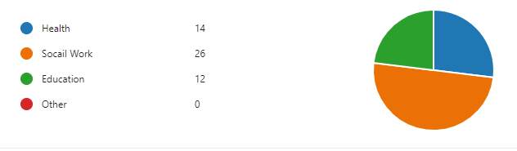

Most responses were from C&F Social Work -50%, 27% Health, Education 23%

**Areas of support required at point of referral.**

Parenting Skills was the highest area identified for support followed by Family Relationships, Emotional Wellbeing and Home Conditions. The previous year confirmed family relationships was highest .

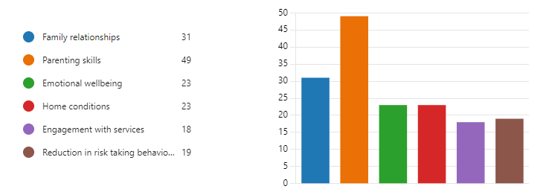

**Feedback on communication with the service**

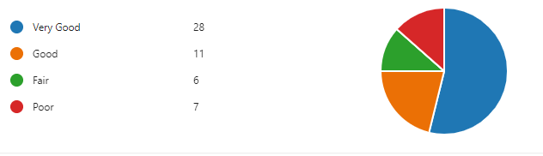

Communication with the service is rated as **very good or good by 75% of respondents**. This has been an improvement in comparison to the previous year. The issues relating to fair, and poor were due to the timeliness of support and will be considered given the timescale from receiving a referral and allocation is **4 weeks.** This can vary due to demand and staffing resource .

**Views on the referral process to access the service.**

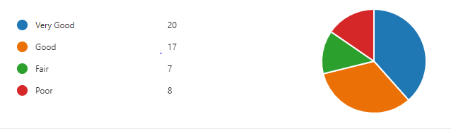

The referral process was in the majority rated **very good and good**, however there were some areas identified that could benefit from further consideration. Referrers highlighted that they found the referral process to be time consuming and the process of submitting via the social work contact centre was not timely or responsive, preferring the previous process of a direct referral to Teams.

**3.0 Delivery**

The gender split in terms of referrals for this period was 362 (58%) Males and 265 (42%) Females which is consistent with the previous year .

Table 2 illustrates the age band split for referrals during the reporting period i.e. **Unborn 1 (0%), ‘00-04’ 92 (15%), ‘05-12’ 359 (57%) and ‘13-18’ 180 (28%).** Again this is consistent with the previous reporting period with over half the children supported within the primary age category .

Overall the same message has come through in the data- **the FSS continue to work across all age ranges but predominantly supporting primary aged children with fits with a more preventative model and earlier approach .**

**Table 2**



**Table 3**



Timescales for support is also an area the service considers , this enables further consideration on the type of support being requested, and whether the service is receiving requests at an earlier stage on the continuum of need **or** for families where additional needs may be more complex.

Table 4 illustrates the number of closed involvements i.e., families who have exited the service totals **756** . This number differs from number of referrals and relates to the number of families receiving a service during the reporting period and who no longer require support during the period .

Of the 756 families closed to the FSS ,**368**  were supported for less than or up to 180 days, this equates to 49% , with 51% supported for longer period . This is an area the FSS are actively considering within the context of WFW and a shift to earlier intervention .A recent audit in the summer confirmed referrals to the service range in complexity further consideration is needed on the delivery of earlier support and advice in line with whole family wellbeing developments .

**Table 4** 

**3.1 Group Work**

Over the last 2 years the FSS has prioritised the delivery of group work which includes evidence-based groups such as Mellow, Incredible Years, Cedar and bespoke groups based on children’s and young people’s issues .

**Cedar groups** - **42** children completed Cedar and 12 were supported through EYDAR. 45 mothers completed the programme , this involved 22 participating in a mother’s groups, 9 at an EYDAR group and 14 on a 1:1 basis.

**Referral breakdown** :36% Health Visitors , 27% Social Work ,21% FSS and Education, 12% Third sector and 4 % self-referrals.

**91%** of mothers shared that they felt more able to keep themselves and their child(ren) safe and **82%** of the children and young people reported they now know how to keep themselves safe.

There continues to be a focus on partnership delivery and 33 group facilitators were trained during this period , this included 27 from the FSS .

**Mellow and Incredible Years groups –** a team has been set up through funding from WFW to build capacity and re-establish evidence-based group work in conjunction with partner agencies and the FSS . Groups delivered in this period are noted in table 5 . It is too early to comment on impact however referral rates have been high and delivery from January 2024 will see an increase in groups across the 7 localities in Fife, supported by staff in the FSS. Learning from this work will be considered alongside other WFW funded work to support service redesign and whole system change .

**Table 5 - March - Aug**

|  |  |
| --- | --- |
| **IY Group** | **Location** |
| Pre- school | Paxton Methil |
| Pre- school | Ladybird Glenrothes |
| Pre- school | Treetop Inverkeithing |
| School Age | Pathhead Kirkcaldy |

In addition to the above there has been group work delivered by all 3 FSS Teams through a more active outdoor focus to support wellbeing and peer relationships , the SWAY link below provides more details .

[Go to this Sway](https://sway.office.com/s8jfxaiONyRrUVXN?ref=email)

**4.0 Outcomes**

The FSS continue to hold 12 weekly meetings to review progress in relation to family support plans and progress using the Outcomes star which is a co-production tool with families measuring change against key outcomes .

Feedback from parents/carers and young people provides insight into the impact of the support offered. From **58** responses from **young people** on views on the support offered this confirmed the following :

**Rating of the support offered** :

**Did the support make a difference.**

**Feedback on what has made the biggest difference confirmed this was relationships.**

Feedback from 122 parents involved in FSS review meetings is summarised below :

**Rating of the support offered** :

**Views on the level of contact**

**

**Overall families have spoken about the importance of having someone to talk to; advice on routines and relationships; having a better understanding of behaviour and strategies to deal with challenges ;feeling less isolated and working better together as a family.**

In relation to the Outcomes star data , 685 Stars were completed in the reporting period . The Outcomes Star has 8 areas which reflect family life and discussion with the family helps track the journey of change and key outcomes relevant to them.

Outcomes evidencing greatest improvements were Emotional Wellbeing **(83%)** and My Children’s behaviour **(81%).** On average 97% of families made progress in one outcome area; 94% of families made progress in 2 outcome areas and 87% of families made progress in 3 outcome areas.

My Star is another tool used in the service to support engagement and participation . This was an area of improvement in the last report. Outcomes evidencing greatest improvements were Feelings & Behaviour (63%), Confidence & Self Esteem (63%) and Education & Learning (63%).On average, 100% of children and young people progressed in at least 1 outcome area; 84% progressed in 2 outcome areas and 74% progressed in 3 outcome areas.

**Workforce Development**

As part of ongoing staff development not only in the use of the above tools but to increase knowledge and competence a programme of training has embedded the Solihull approach and Safe & Together model into practice . In this reporting period a survey of the workforce is summarised below :

Out of 44 responses

* 95% reported they have the skills and knowledge to deliver support and advice .5% who didn’t were new to the service and hadn’t completed all mandatory training.
* 91% reported they were involving children and young people in support plans. More discussion is required on the small number who did not feel this was core to their practice.
* 100% reported they were flexible in their approach and making a difference to families lives.

**5.0 Summary**

Overall, the information in the report confirms:

* Demand for the service continues to be high and referrals range from named persons as well as intensive services.
* Timescales of support are similar to the previous year however there is a need to consider whether earlier support could reduce timescales and resolve issues quicker.
* Overall referrers rate the support on offer as having an impact and making a difference to families lives.
* Relationships within the family is the focus of support for most referrals .
* Processes and access to the service in the main are effective.
* The FSS offer has expanded, and group work is now a core element.
* Feedback for families has confirmed the service is making a difference.
* The workforce is confident and competent , making a difference to families lives.