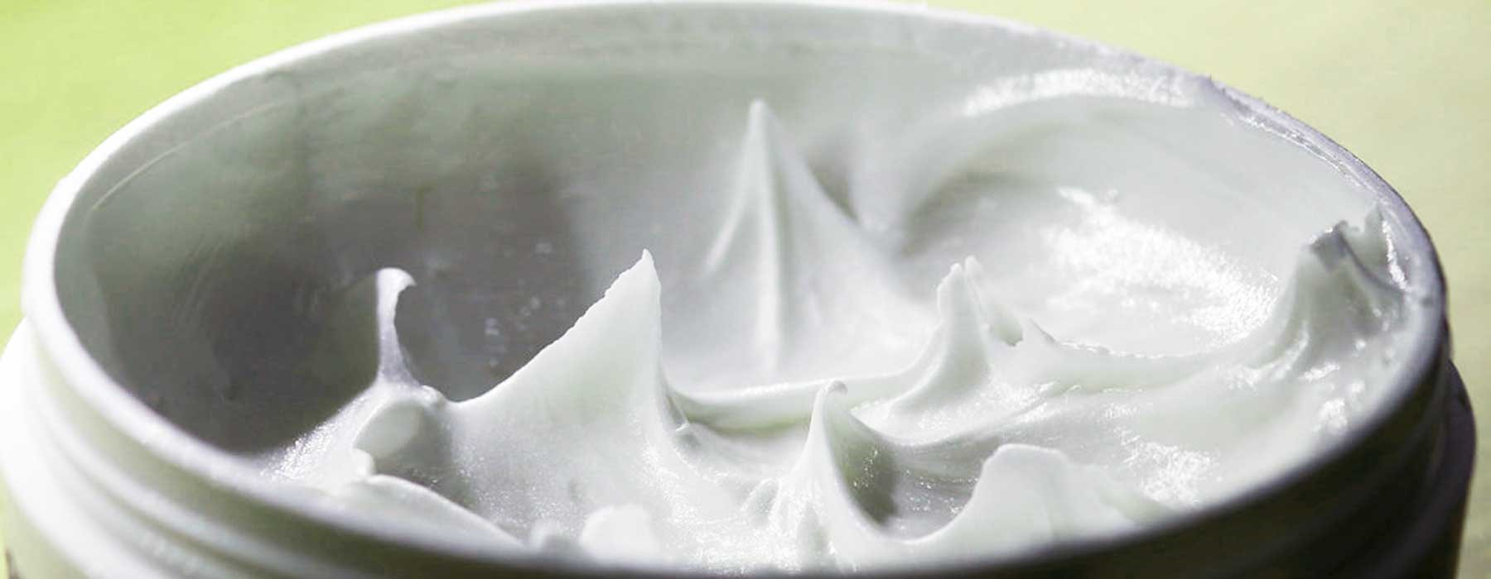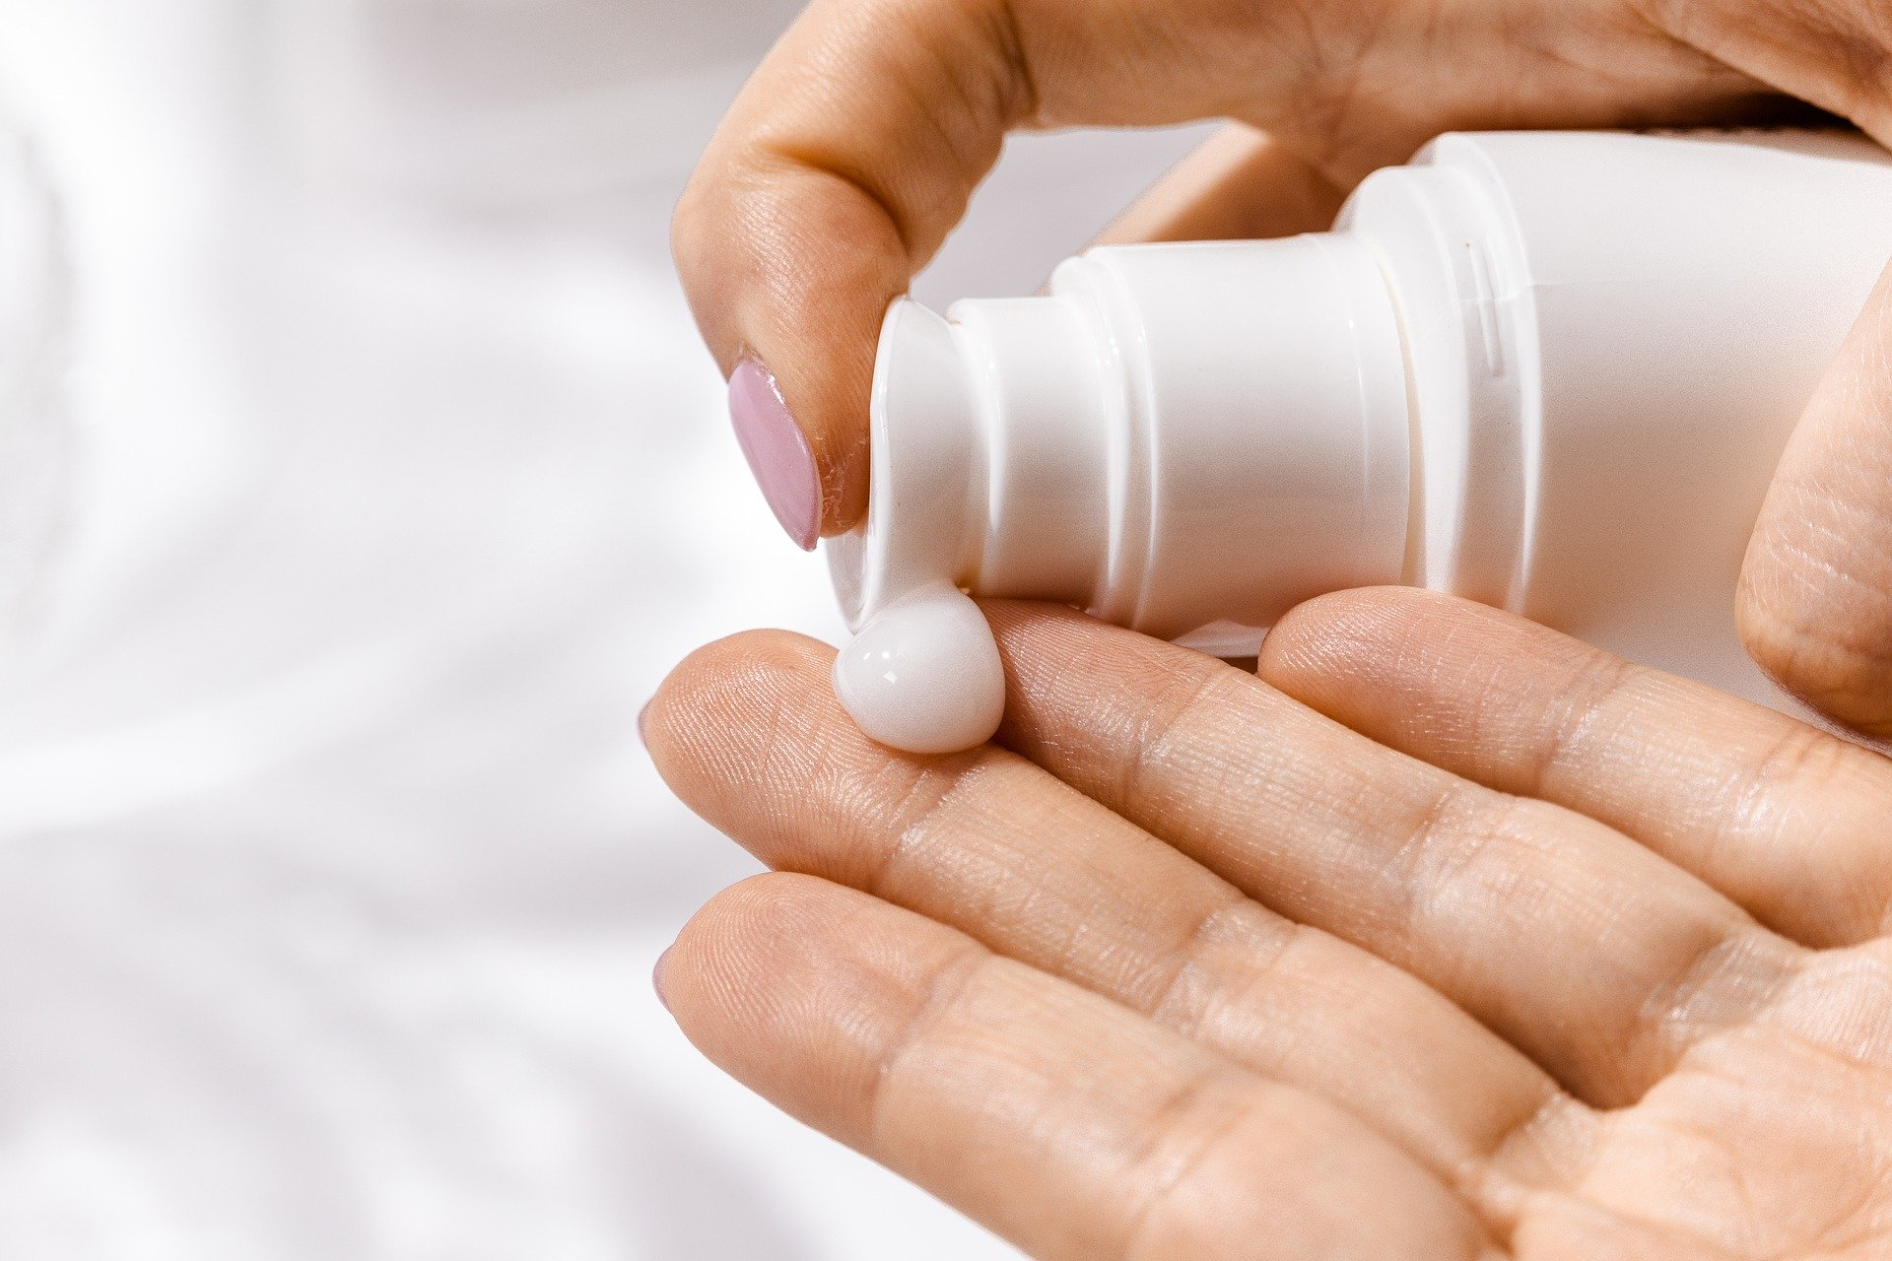

**Emollient Products**

When a paraffin-based emollient product is covered by a dressing or clothing or in contact with bed covers, there is a danger that smoking or using a naked flame could cause dressings, clothing or bedding to catch fire.

|  |
| --- |
| When any fabric has been impregnated with emollient product, there is an increased fire risk as it will ignite more easily, burn more quickly and result in a more intense, rapidly developing fire situation. |

Emollients are widely used to manage dry skin conditions such as eczema or psoriasis. Paraffin-based emollient products are available in various forms, including creams, sprays, gels & ointments. Examples are those that:

* + - * Contain paraffin
* Do not contain paraffin, such as those made with natural oils
* Contain other flammable constituents

* **Do not smoke if fabrics worn or in use are likely to be impregnated (dressings, clothing and bedding) and avoid all naked flames – lighters / matches, cookers and heating devices**
* **Frequently change dressings**
* **Recommend laundering of clothing and bedding more often and at a high temperature (although this does reduce the emollient within the fabric, it will not remove all product and caution should still be exercised)**

**To arrange a Free Home Fire Safety Visit**

**Call 0800 0731 999 or Text ‘FIRE’ to 80800 Or visit** [www.firescotland.gov.uk](http://www.firescotland.gov.uk)

Thank you for your assistance

SFRS Stirling-Clackmannanshire-Fife Community Action Team

