Fife Mental Health & Wellbeing Primary Care Services: Direction of Travel

Introduction

This summary paper outlines the direction of travel for the development and delivery of mental health and wellbeing in primary care services (MHWPC services). It draws from Scottish Government reports and planning guidance geared to the re-mobilisation, recovery and re-design of mental health services in the context of the COVID-19 pandemic, and describes the key principles on which mental health services in primary and community care settings should be designed. The purpose of this summary paper is as an aide to discussion on the design and delivery of MHWPC services in Fife.

Background

The Scottish Government Mobilisation and Recovery Group (MRG) was established to support ‘Re-mobilise, Recover, Re-design: the Framework for NHS Scotland’. Its aim is to ensure key expert, stakeholder and system-wide input into decisions on resuming and supporting healthcare service provision, in the context of the COVID-19 pandemic. The MRG sub-group on Primary and Community Care highlighted the provision of mental health support as a key issue for primary and community services, supporting the parity of esteem between mental and physical health, as we emerge from the Covid-19 pandemic. In response to this, the Short Life Working Group (SLWG) for Mental Health in Primary Care was commissioned to consider how mental health and wellbeing in primary and community care could be delivered better. Its report sets out the principles which should underpin mental health service delivery in primary and community care settings. Subsequent Scottish Government ‘Planning Guidance for Mental Health and Wellbeing in Primary Care Services’ builds on these principles by setting out components which should be considered in the design and delivery of MHWPC services.

Definitions

Mental health in primary care

In the context of the MRG report, “mental health in primary care” refers to a community-based response to the following issues:

- Stress and distress, including the outcome of socio-economic pressures and the consequences of complex trauma and adversity;

- Emotional and relational difficulties;

- Anxiety and depression;

- Wellbeing; and

- Mental illness

Primary care

The term ‘primary care’ can be interpreted in different ways by different services and sectors. The widely accepted interpretation is the local provision of expert generalist skills and interventions (normally provided by general medical practitioners and the primary care team) to a local population. Within mental health services, ‘primary care’ is used to describe a specific level of intervention provided by expert mental health practitioners in any care setting. In the context of the direction of travel outlined, primary care refers to the level of intervention provided by expert multi-disciplinary and multi-agency practitioners in any care setting including, and not restricted to, GP premises.

Service delivery principles

‘Re-mobilise, Recover, Re-design: the Framework for NHS Scotland’¹

The principles for ‘safe and effective mobilisation’ set out in the MRG framework are summarised as follows:

- Achieving greater integration - Building on the important connections and interdependencies between different parts of the health and social care system and with other parts of society;

- Quality, values and experience – Understanding what people most value and building a safe, sustainable, high quality health and social care support system rooted in individual and staff wellbeing;

- Services close to people’s home – Continuing to support the move to more care being provided in the community and closer to home;

- Improved population health – Putting in place services, environments and wider approaches that support people to live healthy lives;

- Services that promote equality – Focusing on how best to support those that are most vulnerable (socially and clinically) in our society; and

- Sustainability – Designing a new sustainable system, focused on reducing inequality and improving health and wellbeing outcomes, and sustainable communities.

‘Report of the Short Life Working Group for Mental Health in Primary Care’²

The ten underpinning principles for service delivery for mental health in primary and community care, and to which MHWPC Services must align and report on, are given in full as follows:

- All parts of the system should enable support and care that is person-centred, looking to access the most appropriate information, intervention and support in partnership with the individual through shared decision making. Trauma informed practice will be the norm. Wherever a person is in touch with the system, they will be listened to and helped to reach the most appropriate place for them – there is no wrong door;

- Primary care mental health services should have no age or condition/care group boundaries, and meet the needs of all equalities groups;

- Local systems will positively seek to address health inequalities, proactively engaging those that are less likely to access support;

- Digital approaches to self and supported management of distress and mental health conditions will be an integral part of the service, with the caveat that those who are digitally excluded need to be engaged positively in different ways;

- Where support can be accessed to help an individual with the primary care setting in their own local area, this should be the default. If referral to specialist services is required, then this should be straightforward and timely;

- People presenting in the out-of-hours period should have access to the full range of options available in-hours, accepting some options may not be available immediately;

- The primary care mental health services linked to a group of practices or a locality to serve a population needs to be developed and resourced to provide appropriate levels of mental health assessment, treatment and support within that primary care setting;

- Staffing levels within primary care mental health services will be subject to, and compliant with, safe staffing legislation;

- Evidence based psychological therapies need to be offered, with appropriate supervision and stepping up seamlessly to secondary care mental health services where appropriate;

- The use of screening and clinical measures pre and post intervention is encouraged, as this can indicate efficacy of intervention as well as assist with triage to ensure people are seen in the right service as quickly as possible.

‘Planning Guidance for Mental Health and Wellbeing in Primary Care Services’³

The Scottish Government planning guidance comprises 59 points which should be used to support the formation and implementation of MHWPC service models, with the expectation that services will be developed incrementally by Spring 2026. The guidance is not intended to define how MHWPC services should be constituted, but builds on the ten principles set out in the SLWG report. The components are fully described in the guidance attached. Those relating to service design and delivery are summarised below:

- Improving mental health and wellbeing in primary care services – MHWPC services should be established within a locality, part of a locality or cluster, and be provided by a multi-agency team providing assessment, advice, support and treatment for people who have mental health, distress or wellbeing needs. Every MHWPC service should provide access to a link worker to support wellbeing. The service should work closely with and/or be part of the wider community team, engaging with the wider assets of the community, health and social work staff and with other agencies as appropriate. There should be named members that work closely with each GP practice to provide continuity and optimise relationships. Access to the service should be based on self-directed care, including self-referral. Timely support and treatment should be provided, with expert GP advice/leadership where needed. Where more specialist input is required, the community mental health team or secondary care mental health services should be accessed seamlessly and in partnership with the practice primary care team. MHWPC services should be delivered by a multi-disciplinary workforce trained in mental health, accessing link worker supports and relevant health and social care expertise. The MHWPC service will not only support the most complex cases, but will provide effective triage and the right level of support quickly. This includes early intervention and prevention to a range of services and supports, including community assets. The MHWPC service should continue to build on collaborations and interdependencies with multiple partners and use digital technology to deliver services.

- Embedded, Aligned or Hybrid model – There are three options available for implementing MHWPC services: 1) Aligning the MHWPC service to a cluster, would mean teams are employed/contracted by the relevant NHS Board. Service Level Agreements for some services could preserve line management and clinical governance for these groups. This model would allow existing limited resources to be distributed where needed, while striving to expand mental health capacity and promote close working relationships with practice staff; 2) Embedding the MHWPC service within general practice settings would mean resources are dedicated to that practice for patient care. The GP practice is a place that patients know and trust and workforce would be based there for a number of days/sessions per week; 3) A hybrid model would include elements of the embedding and alignment models. This could allow flexibility based on population need, rurality and resource. Staff who are aligned with a cluster could complement staff who are embedded in a GP practice. Whichever model is chosen will depend on local needs and existing structures of service provision, but will ease access for patients, including ‘stepping up’ to other primary and secondary care and mental health/psychology services.

- Access – Individuals should be able to access their MHWPC service without the need for a referral from a GP or other professional. Access will normally be through GP appointment systems. MHWPC services will provide mental health assessment, support and treatment across all demographics rather than targeted groups.

- Digital and self-help - Digital approaches to self and supported management of distress and mental health conditions should be an integral part of the service. Those who are digitally excluded, for any reason, should be engaged positively in alternative ways.

- Urgent care - Pathways should be easy to access, quick and responsive at the earliest possible point. Individuals should be guided to the right intervention, support or treatment quickly at whichever point/time they access the system. The MHWPC Service should work with the Out of Hours GP/Primary Care Service and Flow Navigation function (established in each Board to provide access to a Mental Health Competent Decision Maker) to facilitate the ability to make appointments with the team, where appropriate for that individual.

Examples of MHWPC service models

Primary care mental health models in Scotland

There are many examples of primary care mental health models in Fife and in Scotland. Some of these are described in the Scottish Government report, ‘Primary Care Mental Health Models in Scotland’⁴. The aim is to provide an understanding of current mental health service provision in primary care settings and where there are potential gaps, and help inform recommendations on how services can be improved. The models described in the report include the following:

- Patient assessment and liaison mental health service (PALMS) – NHS Tayside
- Occupational therapy (OT) in primary care – NHS Lanarkshire
- Craigmillar medical group mental health model – NHS Lothian
- Accessible depression and anxiety psychological therapies (ADAPT) – NHS Grampian & Lanarkshire
- Primary care mental health service (PCMH) – NHS Dumfries & Galloway
- Compassionate distress response service – NHS Greater Glasgow & Clyde
- The Jigsaw Project – NHS Greater Glasgow & Clyde
- The Govan SHIP Project – NHS Greater Glasgow & Clyde
- The national digital wellbeing hub – NHS Tayside

The success factors that are common across the models cited are summarised as follows:

- Regular reflective practice
- Integration with digital mental health and wellbeing resources
- Many are GP practice based and use the wider multidisciplinary team
- Skilled assessment at the point of presentation improves patient experience
- Continuity and joined up services
- Some highlight benefits to a no referral or discharge system
- AHP ‘request for assistance’ model promotes shared responsibility and decision making
- Training, standardised operational procedures and feedback opportunities
- The models highlight the benefits of cluster working

Primary care mental health models in Fife

Fife already has in place many services that align with the components described in the Scottish Government reports. These include the following:

- Fife Psychology Service delivery of psychological interventions and therapy for primary care and secondary care services, including practice based delivery
- Fife Community Mental Health Teams (including adult mental health and older adults psychology services)
- Mental health triage nurses based in GP practices
- Digital mental health supports via Access Therapies Fife and Moodcafe
- Local area coordinators and community connectors
- The Wells
- Third sector partnerships such as the Link Living Better than Well service; Sam’s cafe; SafeSpaces, Fife Rape and Sexual Abuse Centre (FRASAC), Women’s Aid, Penumbra, Fife Employment Access Trust (FEAT), and Fife One Stop Shop
- Families counselling services via Our Minds Matter and community-based parenting programmes.

Different primary care mental health delivery models have been evaluated in Fife (such as, the All Round Care service; Inverkeithing Medical Practice Mental Health Team). Similarly, community-based approaches relevant to mental health and wellbeing (e.g. Delivering Differently) have been established.

Integrated system to support mental health and wellbeing

The MRG report sets out a model for an integrated mental health system incorporating primary and community care in the diagram below:

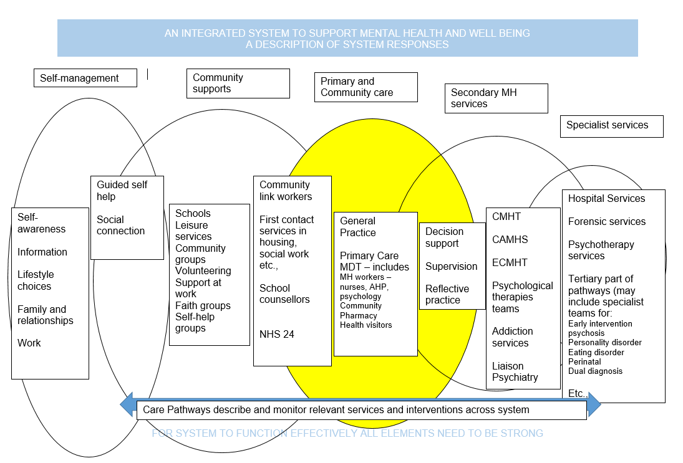
Conclusion

Scottish Government reports and planning guidance describe the principles on which mental health services in primary and community care settings should be designed and delivered and are summarised in this report. The key themes underpinning these can be summarised as follows:

- Patient centred;
- Safe;
- Effective;
- Timely;
- Efficient;
- Equitable;
- Accessible;
- Coordinated;
- Multi-disciplinary/agency
- Relational; and
- Sustainable

DR FRANCES BATY
Director, Fife Psychology Service
January 2022

https://www.gov.scot/publications/re-mobilise-recover-re-design-framework-nhs-scotland/
https://hscscotland.scot/couch/uploads/file/resources/report-test/mhpc-slwg-2021-01-27-final-report.pdf
Scottish Government, Planning Guidance for Mental Health & Wellbeing in Primary Care Services
Scottish Government, Primary Care Mental Health Models in Scotland
https://www.accesstherapiesfife.scot.nhs.uk/
https://www.moodcafe.co.uk/
https://www.fifehealthandsocialcare.org/your-community/the-well
https://www.linkliving.org.uk/our-support/our-services/fife-better-than-well/#:~:text=The%20service%20is%20delivered%20via,negatively%20affected%20by%20childhood%20trauma.
https://www.samh.org.uk/about-us/our-work/sams-cafe
https://www.safespaces.co.uk/
https://www.frasac.org.uk/
https://www.womensaid.org.uk/
http://www.penumbra.org.uk/service-locations/east-area-services/fife/
https://fifeemploymentaccesstrust.com/
https://www.scottishautism.org/services-support/family-support/fife-one-stop-shop

