CROWN ESTATE  GUIDANCE NOTE | 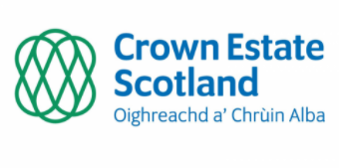 | 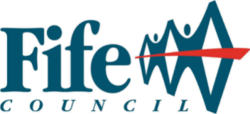
1. Please complete all sections of the application form, indicating ‘not applicable’ where relevant to your project.
2. Projects seeking funding should focus on community priorities and the priorities of Climate Action Fife.
3. Sections of the form will expand should you require more space for your answers.
4. For question 3.9, please add new rows should your project comprise of more than 5 outcomes.
5. Maximum awards will normally be between £30,000 and £40,000. Awards above this ceiling may be considered in exceptional circumstances. Applicants must get in touch to discuss a request for funding above the £40,000 ceiling. Contact email address for enquiries is ashley.birrell@fife.gov.uk
6. Applicants can have no more than 3 awards in a 5-year period.
7. Completed application forms for the 2022 deadline should be emailed to ashley.birrell@fife.gov.uk by Friday 9th September.

