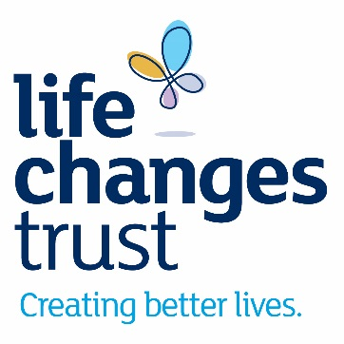
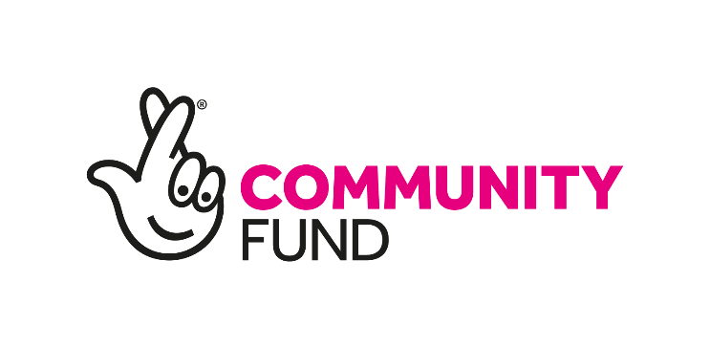

‘CREATING BETTER LIVES IN FIFE’
By local people, for local people: small grants programme

2020-22
Life Changes Trust

Application form

Completing the application

- Please read the guidance notes for Creating Better Lives in Fife Small Grants Programme before completing this form.
- If you have any questions please contact

Louise Buchanan, Senior Funding Officer
louise.buchanan@lifechangestrust.org.uk

Colm McBriarty, Funding Manager
colm.mcbriarty@lifechangestrust.org.uk
0141 212 9063

- Applications must be received no later than 5pm on Friday 4 September 2020.

- Please make sure that your application is submitted to the Life Changes Trust by the deadline. The Trust cannot accept responsibility for applications that do not reach us, for whatever reason.

Your Contact Details
Please provide your contact details below

Title:
Full name:
Job title:
Address:
Telephone:
Email:
Website address:
(if applicable)

Your Organisation

Please provide details for your organisation below.

Name of your group/community/
organisation

What is your role in the group/community/ organisation

Legal status | ☐ Public body  ☐ Registered Charity  ☐ Company Limited by Guarantee  ☐ Private Limited Company  ☐ Community Interest Company  ☐ Other (please state)  ………………………………………………………………………
Please provide any registration details for your organisation (e.g. OSCR or Companies House)
Please state the year that your organisation was established if less than 5 years ago

Your proposal
Please refer to the Guidance Notes for more information on the Trust’s expectations for Creating Better Lives in Fife small grants awards.

Please provide a summary of your overall funding proposal (maximum of 1,000 words).
Summarise:
- What you would like to do

- How this will be done and who it will involve

- If your project will be a continuation of existing work, and/or a development of new work

- How people affected by dementia and/or unpaid carers will be involved in your project

Outcomes
Please tell us what you hope your work will achieve for people with dementia and/or unpaid carers (maximum 1,500 words)

Learning and Sustainability
1. How will you work with other organisations and individuals to deliver a successful project? (Maximum of 500 words).
2. How will you gather and use the learning from your project? (Maximum of 500 words).
3. How will you make sure that the benefits of your project can be continued after the Trust’s funding has ended? (Maximum of 500 words).

Commitment to Collective Learning

The Trust expects the projects it funds to be committed to building relationships with each other in order to learn from each other.

We will ensure that there is sufficient funding in place to support this learning at a regional level. We will also appoint a person/organisation to organise collaborative meetings within the NHS Fife region.

When you submit your budget please make sure you have included a line for travel and accommodation costs for attending approximately four meetings per year.

Please indicate whether or not you are committed to this collective learning:

☐ Yes ☐ No

Staffing Profile
Please provide details of any staff posts you would like the Trust to fund in relation to the delivery of your project.
Please provide information for any member of staff whose costs are included in your proposal (these can be full costs or part costs, e.g. if you would like us to make a contribution to a salary). Insert additional lines if there are more posts.
A job description is required for the post-holder who will be the day to day lead member of staff for this proposal, even if you do not require Trust funding for this post.
If you are requesting funding to employ a new member of staff please attach a draft job description for this post with your application.

Job Title:
Is this a new post? | ☐ Yes ☐ No

Please provide details of any other staff involved in the delivery of your project.

Funding
Please refer to the guidance notes before completing this section.
Funding of between £2,000 and £15,000 can be awarded for your project, which can last up to 18 months.
Costs can include, among other things, awareness raising, planning events, partnership working and liaising with people affected by dementia and/or unpaid carers.
- Please indicate how much funding you will need for your project. You can apply for between £2,000 and £15,000.
Life Changes Trust Funding Request | £
- When do you plan to start your project?

- How long do you expect your project to last?

- Please use the Excel template to complete a draft budget for your proposal. Your proposal will not be considered without this.
Please complete the relevant budget lines – you do not need to use them all. If you require a budget heading which is not in this table, please add it. A column is provided for any match funding, if applicable.
The Total request column should show how much funding you require from the Trust.
If VAT is applicable to any of your costs, please confirm in the notes section which specific costs this relates to.
Please note, Trust funding can only be used to support activities related to the delivery of your project.

Policies
Does your organisation have current policies on the following? Please send a copy of all that apply:
Adult Support & Protection | ☐ Yes ☐ No
Protection of Vulnerable Groups | ☐ Yes ☐ No
Health & Safety at Work | ☐ Yes ☐ No
Reserves | ☐ Yes ☐ No

Accounts
Please provide figures from your latest approved accounts. Please send us a copy of your most recent accounts.
Accounting year ending | Date | Amount
Total income for the year |  | £
Total expenditure for the year |  | £
Surplus or deficit at year-end |  | £
Total savings or reserves at year-end |  | £

If there is anything you want to explain about the figures entered above, please do so in the box below:

Checklist
In addition to your application, please ensure you send us the following documents (if applicable):
- Copy of latest audited/independently examined annual accounts
- Job description(s)
- Supporting statements from partner(s)
- Completed budget sheet with in-kind contribution(s)
- Relevant policies

Please send your application form and supporting documents by email to dementia.programme@lifechangestrust.org.uk

We will send an email to you to acknowledge your application.

General Data Protection Regulation (GDPR)

How do we process your personal data?

The Life Changes Trust complies with its obligations under existing data protection regulation and the General Data Protection Regulation (GDPR) by: keeping personal data up to date; storing and destroying it securely; not collecting or retaining excessive amounts of data; protecting personal data from loss, misuse, unauthorised access and disclosure; ensuring that appropriate technical measures are in place to protect personal data.

We will not disclose your personal information with a third party/third parties.

Your personal data will be sorted and stored securely on the Life Changes Trust’s electronic and paper filing systems.

We will use your personal data for the following purposes:

- To assess your application
- To inform you of our decision regarding your application
- To conduct due diligence (if your application is successful and involves an organisation which plans to support your project)
- To administer a grant (if your application is successful and involves an organisation which plans to support your project)
- To contact you with and for information about your project during the life of your grant (if your application is successful)
- To discuss any other aspect of your project during the life of your grant (if your application is successful)

How long do we keep your personal data?

We will keep your personal data for no longer than is necessary for the above purposes and for addressing any questions that may arise.
We will then delete all of your personal data from the Life Changes Trust’s electronic and paper filing systems (paper copies of your personal data will be confidentially shredded and disposed).

For further information on how your personal data is used, how we maintain the security of your personal data, and your rights to access information we hold on you, please contact:

Admin at the Life Changes Trust on 0141 212 9600 or at admin@lifechangestrust.org.uk

For more information about the Life Changes Trust’s Data Protection Policy, please visit https://www.lifechangestrust.org.uk/privacy-policy

Consent

By ticking the box below you confirm that you have read this GDPR Data Protection Notice and that you are consenting to the Life Changes Trust holding and processing your personal data for the purposes outlined above

Yes, I am happy to consent☐

If you do give consent, please note you can withdraw consent to all or any one of the above purposes at any time by contacting 0141 212 9600 or emailing admin@lifechangestrust.org.uk. Please note that all processing of your personal data will cease once you have withdrawn consent, but this will not affect any personal data that has already been processed prior to this point.

