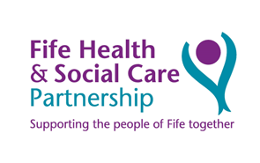
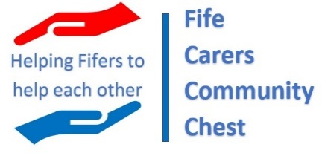
Application Guidance
Background
Fife Carers Community chest aims to fund local projects, which are for the benefit of unpaid carers. In Fife there are over 35,000 unpaid carers and our aim is to fund community projects which will allow unpaid carers to create supportive places, develop their sense of belonging and improve their wellbeing through this funding.

Who is an unpaid carer
A carer is someone who, without payment, provides help and support to a relative, friend or neighbour who can’t manage without their help. This could be due to age, physical, or mental illness, addiction, or disability.

Who can apply
The funding is available to any carer led community group/charity etc based in Fife who want to offer support to unpaid carers in their community. The primary beneficiaries of the funding must be unpaid or informal carers.

If you are not an established group, you can access the funding however forming a community group and becoming constituted is essential. Advice, guidance, and support to form a constituted group is available from Fife Voluntary Action (www.fva.org/organisation_support.asp). You can still apply for the funding, whilst in the process becoming constituted however for the funding to be awarded all groups must provide evidence of being constituted.

Funding available
Community groups can apply for funding up to £10,000 for projects. Funding of £350,000 has been allocated as a one off and all projects need to ensure they are sustainable after the funding ends.

Standard grant conditions of Fife Health & Social Care Partnership will apply.

The funding can only be used for projects that are within Fife and benefit unpaid carers who undertake their unpaid caring role in Fife, i.e., the cared-for person lives in Fife. We will only consider one application from pre-existing groups.

Project suggestions
Examples of projects might include (but are not limited to):
- Local carers café, supper clubs, coffee mornings, warm venues
- Carers art and crafts clubs or projects
- Shared allotment or gardening projects
- Sports and fitness - carers walking or cycling clubs, ladies swimming clubs, golf groups
- Creative cooking classes
- Creative reading and writing groups or book clubs
- Music and singing lessons
- Locality theatre group
- Creation of a new local carers support group

Costs
The project will consider support for reasonable costs that are noted in a successful application provided they are not for personal or individual gain. Each project will be required to fully account for its expenditure. The grant application will include details of the costs they will incur to deliver the project. All used funding must be returned to the partnership and if the project exceeds the anticipated budget, further funding cannot be provided.
Typical costs may include ongoing running costs, some one-off costs, and some start-up costs.
For example:
- Venue hire
- Equipment and furniture hire or purchase
- Promotional material and publicity
- Travel and accommodation
- Staff and volunteer nominal expenses e.g., additional mobile phone or broadband costs
- Licences and permits
- Volunteer recruitment, training, and support
- Consumables e.g., printing, stationery, postage

The grant is available to support additional costs associated with the projects whose application is successful. It is not intended to cover or contribute to the costs of paid staff already in post. We expect any organisation that applies for funding to cover such reasonable staffing costs from their own resources.
Funding is available for capital items with a significant retained asset value at the end of the project.

Timeline for applications
The fund will open on 5th June for applicants to submit their application form.
The following timeline is an estimation:
5th June 2023 - The Community Chest Fund opens – applications submitted to email address
31st July 2023 - The Community chest Fund closes – applications will not be considered after this date
31st August 2023 - Decision of application communicated to applicants by this date
Please be aware that the panel’s decision on the fund is final and if there are funds unallocated there might be further rounds of funding.

Project evaluation
We recognise the value of the grant offered is modest and while we are seeking to learn from each project about its impact, we will keep the evaluation simple and to a minimum with only three key elements:
- A short report of achievements against the outcomes and impacts noted in the application, including the number of people benefitting.
- An anonymised case study that can be used to promote the challenge fund in the future.
- A final income and expenditure report for the project showing how public funding was used.
At the end of each year a compendium of projects will be produced to illustrate the impact of the challenge fund. This is a critical element for the overall fund to secure longer term funding.

Applications will be assessed on
Applications will be subject to consideration and evaluation by an independent panel of experts, which will include carers representatives and professionals from third sector organisations who support carers. The criteria against which the applications will be assessed include:
- The nature of the proposed project and the number of carers supported.
- The number of carers benefitting from the project (and the number of non-carers benefitting).
- Previous and/or matched funding for the project or group.
- Risk assessment and overall value for public money.
- The spread of applications from each locality is supported and knowledge of similar projects in the locality.
- Agreement to partnership working and shared learning.
- Value of reserves available, if any.
At its own discretion, the governing body may set additional criteria by which they assess all applications.

