
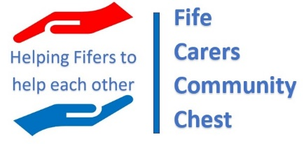
Application Form

Introduction
This application form is for community groups that are interested in applying for funding to create new support opportunities for unpaid carers in their community.
Please read the accompanying guidance notes before completing this form.
Applications for round one of the grants must be received by 10am on 31st July 2023.

Your contact details - Please provide the details of the lead applicant and seconder:
 | Lead applicant | Seconder
Title and full name:
Address:
Telephone:
E-mail

About your community group:
Is your community group already established or constituted?
If yes, please provide the following registration details: | Company number:  Scottish Charity Number:
If not, are you willing to formally establish or constitutes your group?

Project Idea – your proposal
In which locality in Fife will your project be?
Summarise your project’s aims. Refer to the Guidance Notes for more information on the expectations for this community chest. (Maximum 500 words).
What benefits will your project deliver for unpaid carers and what positive difference will it make? (Maximum 200 words).
When will your project start and end? | Start date:  End date:
Who will be involved in the delivering your project?
How many unpaid carers will benefit from your project?
How many non-carers will benefit from your project?
How will you promote and raise awareness of your project to unpaid carers in your locality? (Maximum 100 words).
How much funding are you asking for to make your project successful? Please list all elements of over £1000 in value.
What specifically will the funding be used for? (Maximum 200 words).
Is the Fife Carers Community Chest the only source of funding?
Please list any other funders and funding involved in the project.

Please confirm that your community group already have policies/measures in place to cover provide the following assurances, or is willing to work to develop these?
 | Already in place | Willing to put these in place
Awareness and practices in place that meet the requirements of the General Data Protection Regulation?
Awareness and practices in place that meet the requirements of the Protection of Vulnerable Groups requirements?
Awareness and practices in place that meet the requirements of the Risk, insurance, and indemnity?

Please confirm you have read and fully understood the application guidance and the commitments you will be making if your application is successful.

Signed: Date: (Lead applicant)

Co-signed: Date:
(Seconder)

