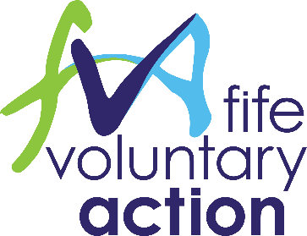

Fife's Community Engagement Champions Group
Friday 01 February 2019
1.30pm to 4.00pm
Craig Mitchell House, Flemington Road, Glenrothes, KY7 5QF

Agenda

- Welcome
- History / background of Fife’s Community Engagement work
- Fairer Fife funding
- Role and Purpose of Fife’s Community Engagement Champions group
- Group exercise – Making the plan a reality! – Achieving Community Engagement Outcomes
- Future dates and content of FCEC group meetings

