AIRLIE CANCER CARE ASSOCIATION

Come together for an informal
chat and support

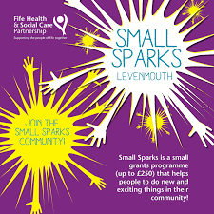
Our monthly group is re-starting for 2023. This group has come together to support patients and their families who have recently (or in the past) had a diagnosis of Cancer. We have been lucky to receive some funding through Small Sparks Levenmouth as well as donations to enable our group to run and benefit the people of Levenmouth.

A very informative group with representation from our local Listening Service, Fife Forum, Health & Social Care Partnership—Improving Cancer Journey. We also organize other speakers to come along to offer advice and opportunities. Our group is open to anyone registered with a GP in the Levenmouth area. Why not pop along for a friendly get together, cup of tea/coffee and a light lunch.

All meetings are held on a Thursday in
Buckhaven Theatre, Lawrence Street, Buckhaven 1.30 p.m - 3.00 p.m.
23rd February 2023
23rd March 2023
20th April 2023
25th May 2023
22nd June 2023
27th July 2023

Any questions or feedback please contact:
Mrs Tracy Simpson, Practice Manager, Airlie Medical Practice, 01333-426083
tracy.simpson@nhs.scot
Mrs Jacqueline Thomson, DCS, Community Chaplain NHS Listening Service, 07806776560
Jacqueline.thomson@churchofscotland

