Citizens’ Panel

A personal invitation to join our Citizens’ Panel
Have your say on Scottish health and care decisions.
People in Scotland are being invited to have their say on the future of the nation's health by joining our Citizens’ Panel.

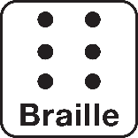
Healthcare Improvement Scotland - Community Engagement is committed to inclusive communication. We are happy to consider requests for other languages or formats:
For any questions or further support needs please contact our Project Officer.
Susan.mclaren1@nhs.scot
Translation
BSL
Audio
Large print
Braille
Easy read
07866130811

What is a

What is a Citizens’ Panel?
A Citizens’ Panel is a group of people who reflect Scotland today. Our Citizens’ Panel involves around 1,000 of the adult (16+ years) Scottish public recruited from all over the country. The panel are asked about a range of issues, providing an opportunity for people to have their say on health and care. The public’s involvement help us make decisions that are important to those who use the services. For example, recent panels have given their views on health and social care priorities during the COVID-19 pandemic, dental care, and the inclusivity of COVID-19 vaccination.

Feedback from the Citizens’ Panel, run by Healthcare Improvement Scotland, is used to help make decisions and shape services to make sure they meet people’s needs and take account of their views.

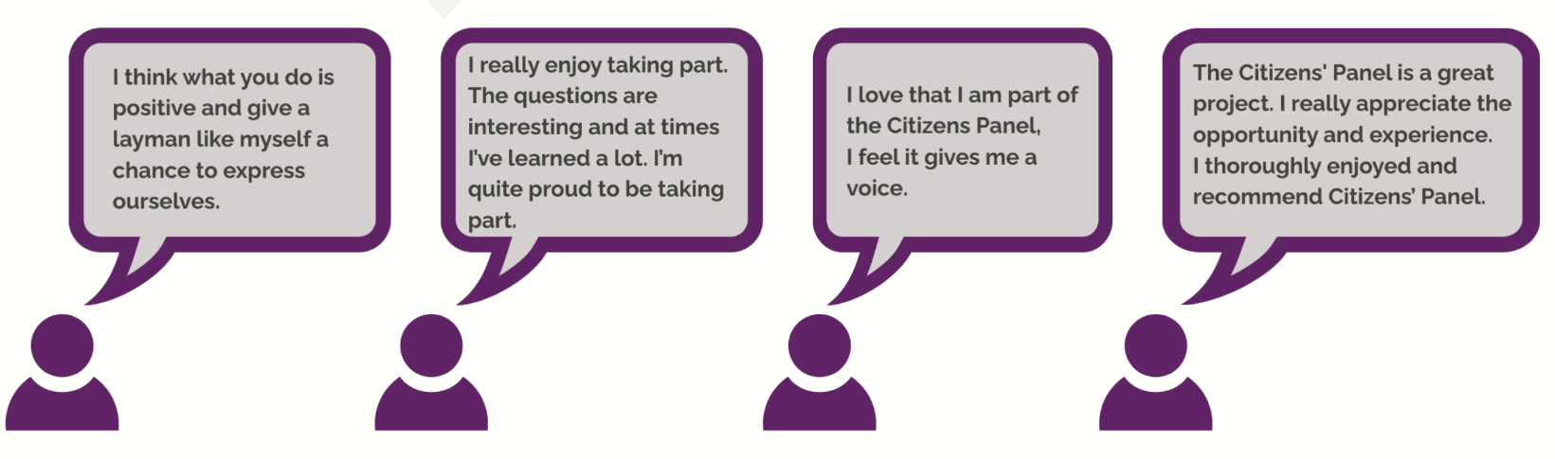
Don’t take our word for it, here’s some of the thoughts of previous panel members after taking part:

Humza Yousaf, the Health Secretary for Scottish Government, said about recent Citizens’ Panel work:

“We welcome this report which provides valuable insight into experiences of public engagement in the design and change of health and social care services.”

“This is very valuable feedback and officials will want to consider the results of the Citizen’s Panel in terms of further policy development.”

What will I need to do?
- Take part in two to three activities a year. These are mainly surveys, but there may be opportunities to give feedback through interviews or discussion groups. You can choose how participate, for example online, via post or telephone.
- Give your opinion on a variety of health and social care topics.
- Contribute towards shaping and influencing national policy to improve.
- You will receive the results of activities you’ve taken part in, for example published reports, so you will know how your views are used and leading to change.
- For more information about Healthcare Improvement Scotland’s Citizens’ Panel visit: https://www.hisengage.scot/informing-policy/citizens-panel/

Can I leave if it’s not for me?
- Yes! Being part of the panel is completely voluntary and members can leave at any time. You don’t need to have any special skills or knowledge, and your feedback will help to improve health and social care services for everyone.
- All the personal information you provide will be confidential and you can always decide at the time of the survey being sent out, if you want to take part or not.

How do I join?
To register interest to join our Citizens’ Panel please complete this online form from the link below
www.researchresource.co.uk/Citizenspanelengagement.html
If you require a paper copy then please contact our research partners Research Resource at the email address or phone number below giving your address and contact details.

If you have any questions about joining the Panel, contact Research Resource on 0800 121 8987 or info@researchresource.co.uk
We cannot guarantee that everyone who expresses an interest in joining the Panel will be chosen, however we will store your details safely and may contact you at another time to join the Panel when appropriate.
Lindsey McNeill,
Interim Director,
Healthcare Improvement Scotland – Community Engagement

