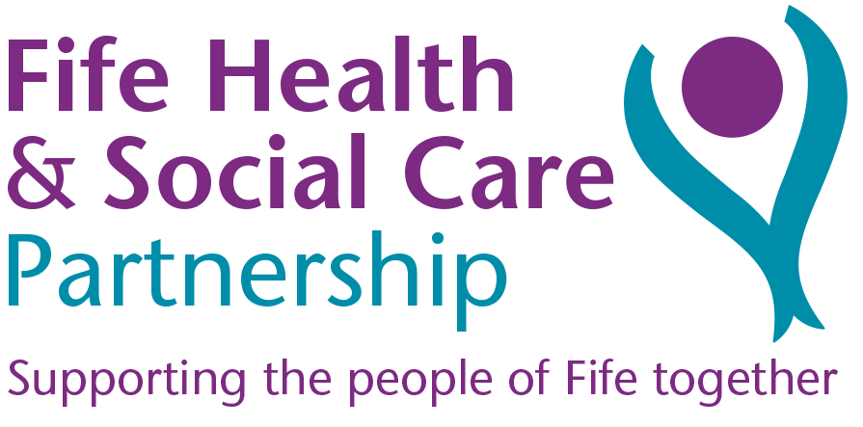
Can you help us to redesign our Community Hospitals and Intermediate Bed Care?

Community Hospital & Intermediate Care Redesign Event
15 August 2018, 0930-1630, Lynebank Hospital, Dunfermline

We would like you to work with us to improve the experience for people who require care to recover after an illness or injury. You can help us develop the options for how we best provide care in our Community Hospitals and Intermediate care beds across Fife by participating in our redesign event.

Why we need to change
- At any one time, around a third of people in our community hospitals could be cared for in a different way and in a different place
- We need to support people’s wish to stay at home or near to home rather than be in hospital – we know that we do not have enough beds in some areas
- Some of our community hospital buildings are old and won’t be suitable in years to come
- We need to respond to our growing and ageing population now

We are having an event on the 15th of August to develop a number of options in relation to how we deliver services in the future.

We are looking for members of staff along with public, patients and carers to work with us and help develop the potential models for Community Hospital and Intermediate Care Beds. There will then also be opportunities to join in an option appraisal process in September and wider engagement later in a full public consultation.

We encourage you to come forward to help inform and shape the future of services. Together, we want to ensure people get the right care, by the right person, at the right time.

If you would like to attend the Community Hospital and Intermediate Care Redesign event please contact us to reserve a place as below. Please note places are limited.

- Call: 01383 565 199 or
- Email: fife-uhb.joiningupcare@nhs.net (mark as Staff Event – 15/8/18 in header) or
- Return the tear off slip below:-

I would like to attend the Community Hospital & Intermediate Care Redesign Event to be held on 15 August 2018, 0930-1630, Lynebank Hospital, Dunfermline

Name: ………………………………………….. Email ………………………………………
Designation: ………………………………………….. Tel. ………………………………………
Base: …………………………………………..

Return to: Joining Up Care Team, Tower Block, Lynebank Hospital, Halbeath Road, Dunfermline, KY11 4UW

