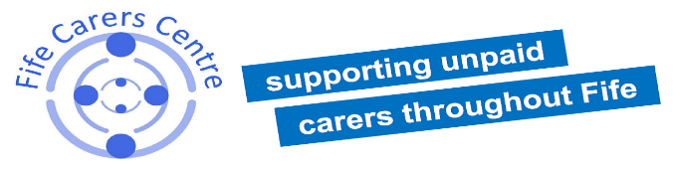
CARERS CATCH UP CLUB
GROUP BEFRIENDING
If you are an unpaid carer in Fife - this group is designed for you!
Come and join our friendly club to find companionship, peer support, meet people who are in a similar situation: caring for an elderly person, adult or a child;
try some fun activities, have a cake and a cuppa, socialise and get information
Supported by Fife Carers centre volunteers and staff
Every second Tuesday 1-2:30pm
At the Linton Lane Centre, Linton Lane,
KY2 6LF Kirkcaldy
For more information contact Sylwia at Sylwia.nadolny@fifecarers.co.uk or 07736909692
You may also join us for a walk before the Club at 12pm, meeting at the Linton Lane Centre car park

Company Number 282309 Scottish Charity No SCO29468

