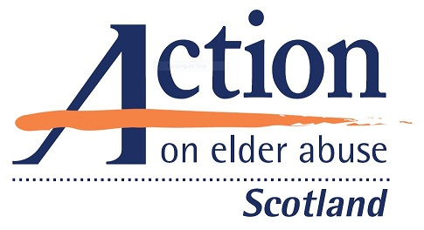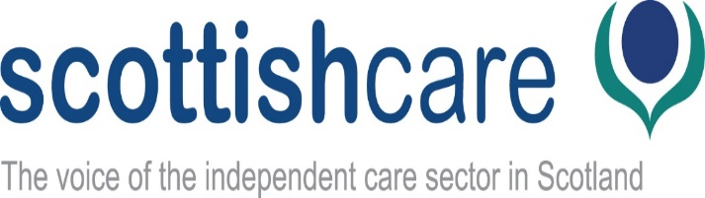

Booking Form

Action on Elder Abuse Scotland National Conference (in association
with Scottish Care)

Choice, Empowerment, Protection… Can we achieve
them all?’
A human rights-based approach to supporting, empowering and protecting
older people

Your details
Title: | Name:
Job title:

Organisation:

Address:

Postcode: | Tel. no:
E-mail address:

Payment
AEA members receive a 20% discount on all AEA conferences, training, seminars and 15% discount on DVDs and publications for one year. You may therefore want to consider becoming a member to qualify for the reduced booking fee for this conference, which will offer further discounts for the next year.

☐ I am / my organisation is an AEA member Membership no: ……………….

Members’ booking fee: £24 (plus VAT) = £28.80

☐ I am / my organisation is not an AEA member

Non-members’ booking fee: £30 (plus VAT) = £36

I wish to apply for AEA membership (membership is for 12 months):
☐ Individual: £21 ☐ Group membership (for up to 20 people): £52

We can take your membership payment now, and send your membership papers by e-mail or post when the payment is processed.

Payment options - please choose from one of the following:

☐ I would like to pay by card on the AEA website (please go to https://elderabuse.org.uk/scotland-conference/)

Payment total: £….. (please insert total - including membership fee if selected)
☐ Please send me an invoice to the address above

Payment total: £…. (please insert total - including membership fee if selected)

Purchase order no:

Address for invoice (if different from above):

Cancellations: we are unable to offer refunds in the event of cancellations (unless the event is cancelled). You can, however, transfer your place to someone else if you are unable to attend the conference.

Additional requirements
Any special dietary requirements:
☐ Vegetarian ☐ Gluten free
☐ Vegan ☐ Other (please specify):

☐ I require materials in large print (please specify font size)
☐ I am a wheelchair user ☐ I require materials to be sent electronically
☐ I require BSL interpretation* ☐ Other (please specify):

* if you require BSL, please submit your booking form by 16th October .

Booking confirmation will be sent by e-mail. If you do not receive confirmation within 1 week, please contact us on 0208 835 9280.

We will contact you with details of workshop choices when the full programme has been confirmed to allow you to choose in advance.

Please return your completed booking form to:
E-mail: confscotland@elderabuse.org.uk

Post: AEA Scotland Conference
Action on Elder Abuse
PO Box 60001
Streatham, SW16 9BY

