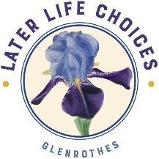 Later Life Choices Glenrothes

Annual General Meeting

Wednesday 23 November 2022 at 4.00pm

held at Glenrothes Training Room, Fife Voluntary Action,
Saltire Centre, Caledonia House, Pentland Park, Glenrothes

A G E N D A

- Welcome from the Chair

- Apologies

- Minutes of 24th Annual General Meeting of 16th February 2022

- Matters arising

- Presentation & adoption of accounts for 2021/2022

- Retirement/election/re-election of Directors:

AGM approval sought for the following:
- that Rick Kiralfy be re-elected as Chair
- that Sharon King be re-elected as Treasurer
- that Alexandra (Sandra) Moffat be elected as a Director

- Report by Service Manager

- Statements of appreciation from Clients

- Questions from the floor

- Vote of thanks and close

