Hoarding and Self Neglect Multi-Agency Consultation Group
Do you have input with someone who hoards in Fife and are you looking for advice, guidance, or signposting?
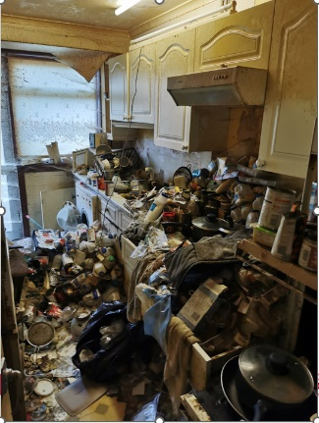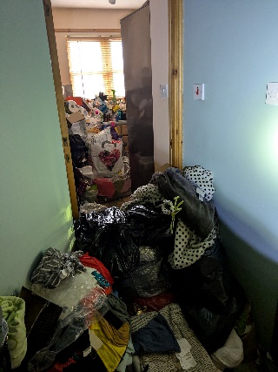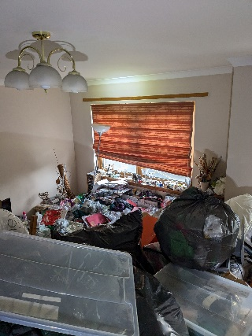

The Hoarding and Self Neglect Working Group have representatives across Health, Social Work, Fire, Police, and Housing Services. We meet every quarter to discuss training and education issues around self-neglect and hoarding and we are commencing a consultation group that will be open to any frontline worker across Fife.
People who hoard often come into contact with many different agencies and it can be difficult for workers to know what various agencies could offer, and who would be best placed to offer support. Furthermore, because of the various agencies involved, it is a challenge for frontline workers to be aware of service eligibility criteria, key locality contacts, and ways of working. The Consultation Group will allow any worker to bring a case to the multi-agency group for advice and signposting to help with these issues.
Process/Terms of Reference
- The Consultation Group will meet over MS Teams as part of the existing Adult Support and Protection Committee Hoarding and Self-Neglect Group. These meetings take place each quarter.

- Referrals can be made to each relevant agency’s representative via the Good Practice Storyboard (see appendix 1) These identified reps will have up to 30 minutes to discuss the case at the Consultation Group. Reps will receive feedback, questions, and signposting from the Group. Currently there are representatives from Social Work, Mental Health, Fire, Housing and Police. Each meeting will discuss 2 cases maximum per meeting to ensure effective analysis and discussion.

- The purpose of the meeting will be to consider potential next steps with the case being discussed or identify local service specific contacts that may be of use for follow up. Feedback will be given via meeting minute.

- Importantly, the Group will only be offering consultation and not taking ownership of any cases being discussed.

Eligibility
- If you have direct one to one work with someone who hoards and they live in Fife.
- We would be keen that the Consultation Group is available to any service that offers direct input to individuals (i.e. one to one work, health input, domestic work, environmental work etc)

If you have a case that you wish to bring to the Group please email your relevant service leads to discuss your referral in the first instance. Once referral is agreed, please complete the Good Practice/Storyboard template below and submit to: ASPC.Admin@fife.gov.uk

Members of Hoarding and Self-Neglect Consultation Group

Claire Chrystal (Chair), Detective Inspector Police Scotland
Claire.Chrystal@scotland.police.uk
Ronan Burke, Service Manager, Public Protection, Fife Council
Ronan.burke-sw@fife.gov.uk
Sherrin Woods, Adult Support and Protection Coordinator
Sherrin.Woods@fife.gov.uk
Evelyn Taylor, Scottish Fire and Rescue Service
evelyn.taylor@firescotland.gov.uk
Dr Tom Nisbet, Principal Clinical Psychologist, Older People's Psychology Service, NHS Fife
tom.nisbet2@nhs.scot
Sue Knox, Senior Practitioner with a specialist in Hoarding, Social Work, Older People’s Services
Sue.Knox@fife.gov.uk
Claire Mackinlay, Team Manager, Housing Service, Fife Council
Claire.Mackinlay@fife.gov.uk
Ewa Golebikowska, Social Worker, Older People’s Services
Ewa.Golebikowska@fife.gov.uk

Appendix 1

Hoarding Consultation Group
Storyboard completed by
Service
Name / job title
Date of evaluation report
Service User Details
Name
Date of Birth
Address

CHI No.
Evaluation Details
What information or support would you be looking for from the H and SN Consultation Group?
What have you tried so far to help, and how has that worked?
What are the identified risks?
What number on the Clutter Image Rating Scale (CIRS) is this adult’s level of hoarding assessed to be? (1-9)
Does the adult have any diagnosed hoarding disorder? (Or any related diagnosis which may impact on hoarding)
Which agencies are involved?
Has the adult been supported to give their views? If so, how?
Summary of Evaluation/Reflection
Have you identified any areas of good practice thus far?
What areas for improvement have been identified?

If an action plan has been compiled, when is this expected to be completed and who has responsibility for doing so?
Has any consideration been given to Non-ASP Adult Case Conference?
Recommendations from the Group to consider:

