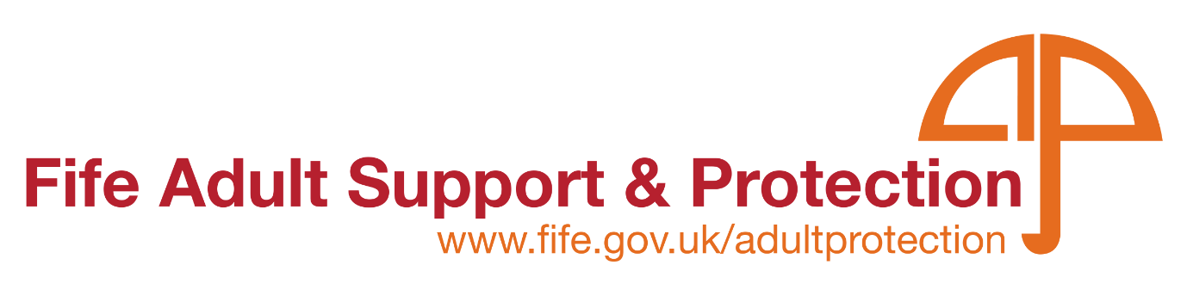

ASP - Multi-Agency Vulnerable Young Person’s Protocol – Awareness Session

**Who should attend:**

This online webinar is relevant for all multi-agency partners including Social Work, Education, Health, Police, Housing, Scottish Fire and Rescue Service, Third Sector, and any other partner, working with young people aged between 16 and 25.

We are currently offering 3 x one-hour long awareness sessions. These will be held via MS Teams and will be Instructor led.

**What you’ll learn:**

This webinar is being held to raise awareness of the ‘Multi-Agency Vulnerable Young Person’s Protocol’ prior to its implementation across Services.

This protocol can be used by all practitioners to identify the most appropriate safeguarding approach for reports of harm relating to children and young people aged 16-25.

**Available dates:**

* Thursday 26th June 2025 - 2pm – 3pm
* Friday 4th July 2025 – 10.30am – 11.30am
* Wednesday 16th July 2025 – 10.30am – 11.30am

### Application Form

If you would like to book a place on a course and **are not a Fife Council Employee,** please fill in the application below and return it to – [**LearningAdminBusinessSupport@fife.gov.uk**](mailto:LearningAdminBusinessSupport@fife.gov.uk)

Our courses are offered free of charge; however, it is vital that notice is given when people are unable to attend to ensure maximum places are offered to colleagues across all services. There will of course be occasions where it is not possible to make contact prior to the start of the course. Please ensure contact is made as soon as possible following to advise of reason for non-attendance.

|  |  |
| --- | --- |
| Course Title in Full: |  |
| Date of the session you wish to attend: |  |
| Name: |  |
| Job title: |  |
| Organisation/ Service: |  |
| Address (including postcode): |  |
| Telephone No: |  |
| Email Address:  Essential for MS Teams link |  |
| Line Manager email: |  |